GEM Awards 2016
Going the Extra Mile for our customers

Category
teaming up

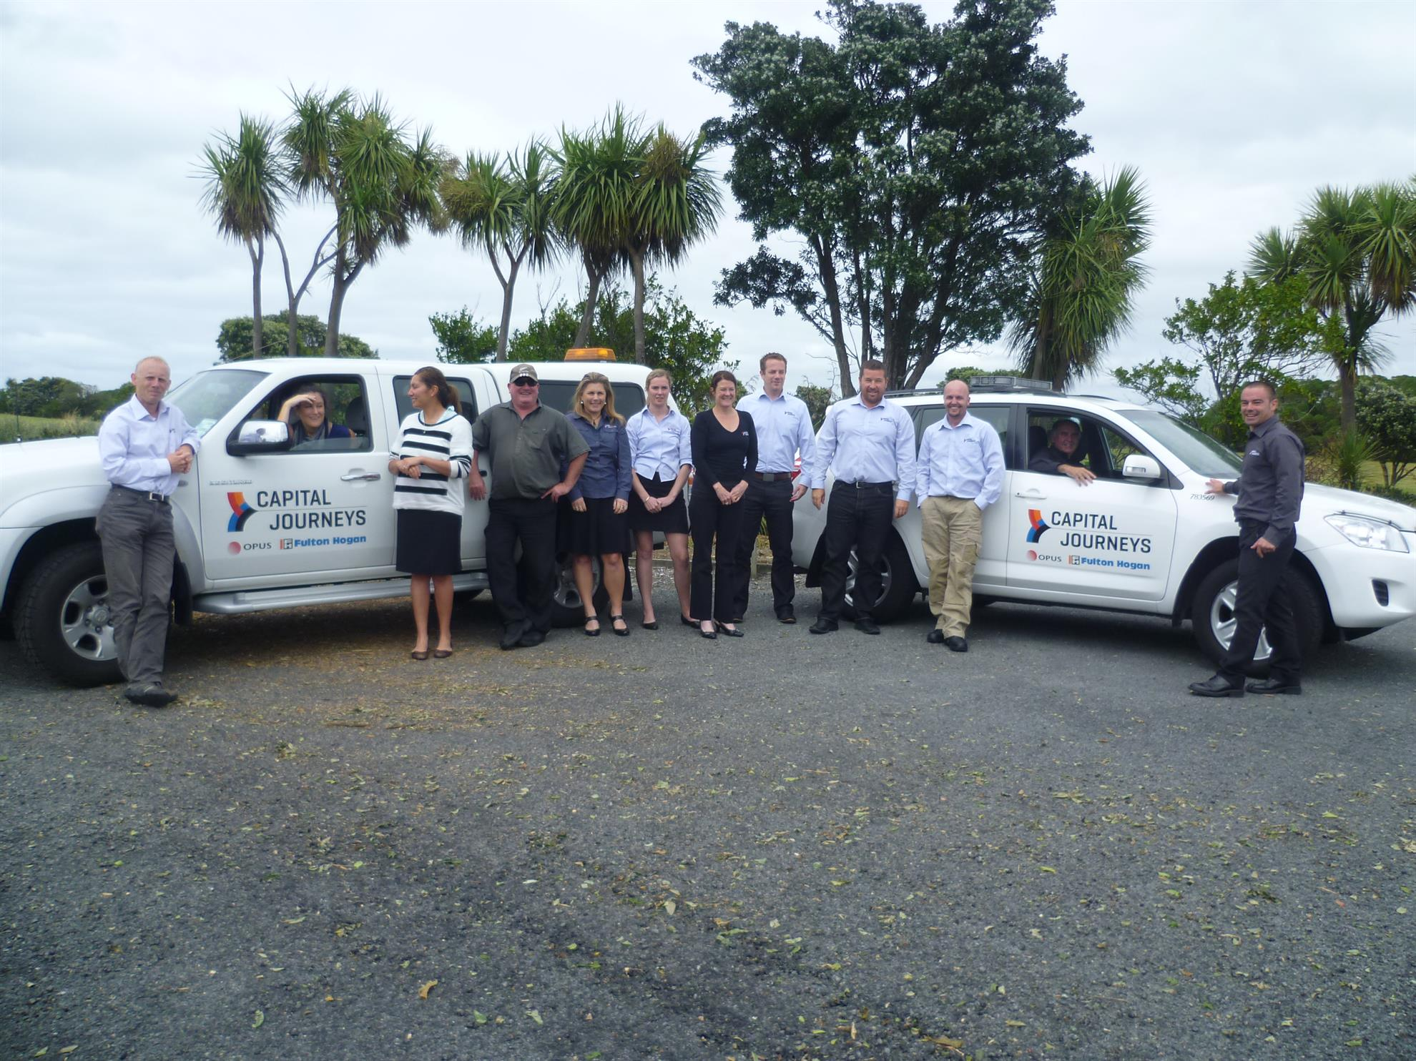

Company information

Please complete your company information here

Name of entry:

Company details
Company:
Company address:
Main activity of company:

Contact details:
Name:
Title:
Telephone number:
Email address:
Postal address:
(if different from above)

Terms and conditions
I hereby apply on behalf of my organisation for entry into the 2016 NZ Transport Agency GEM Awards and agree to be bound by the relevant terms and conditions.
I declare that all information supplied is accurate and that I am an authorised representative of the named company/organisation.

Signature: Date:

Objectives & Submission
Guidelines to help with your application

Entry guidelines
Completed entry forms will be in electronic format and need to be received by 12 noon on Friday 15 July 2016.
- Please use the word template to complete your entry with a maximum of 2000 words per entry
- PowerPoint presentations need to be completed in the template provided, and are supplementary to your submission
The headings below are the key elements your entry should cover, with the following bullet points providing a guide to what we would like you to demonstrate/provide with your application:
- Customer quotes or interviews to support your entry
- Supporting images (need to be high resolution, i.e. above 2MB)
- Video footage to support your application (this can be supplied as an attachment with your application).
For shortlisted entries, all images and text become the property of the NZ Transport Agency and will be used to further support the ongoing story of ‘Going the Extra Mile’.

Objective
Demonstrate how your company has effectively collaborated and teamed up in your delivery of projects or programmes.
Company philosophy
- What are the aims and philosophies of your company, particularly in regard to teaming up and collaboration with other organisations?
Management and leadership
- Comment on how you translate the company’s collaboration philosophy within your organisation and across your business activities.

- To what extent do you collaborate with other organisations (including any sub-contractors) to achieve outcomes for the Transport Agency?
Systems and practice
- Provide examples of innovative collaboration and ‘Teaming Up’ practices within your organisation and with other organisations that has improved the service delivery to the Transport Agency and our customers.
People
- How do you train to increase, and then monitor, the collaboration capability amongst your staff?

- Provide example(s) of your team’s approach to working with other organisations in delivering service and programmes to the Transport Agency.
Striving for success
- Comment on how ‘Teaming Up’ improvements are driven within your organisation and provide examples of where initiatives have been picked up for wider use across the company.
Results
- Can you demonstrate in specific actions, activities and results where your company has shown collaboration and ‘Teaming Up’ in your business delivery for the Transport Agency’s projects or maintenance activities?

Award information

Important information before submitting your application

Award details
Finalists will be invited to attend the awards ceremony in Auckland on 22 September 2016 at the Maritime Museum, Viaduct Basin. There is no charge to enter the awards.

Finalists will be notified via email from gems@nzta.govt.nz by the end of August 2016.

GEM Award templates
How to find and download our templates

Word template
To download your Word template click here.
Alternatively you can visit www.nzta.govt.nz/gems and download our forms there.

PowerPoint template
To download your PowerPoint template click here.
Alternatively you can visit www.nzta.govt.nz/gems and download our forms there.

