Accessible Streets – Summary to the Overview

9 March 2020

Copyright information
Copyright ©. This copyright work is licensed under the Creative Commons Attribution 4.0 International licence. In essence, you are free to copy, distribute and adapt the work, as long as you attribute the work to Waka Kotahi and abide by the other licence terms. To view a copy of this licence, visit http://creativecommons.org/licenses/by/4.0/.

Disclaimer
Waka Kotahi has endeavoured to ensure material in this document is technically accurate and reflects legal requirements. However, the document does not override governing legislation. Waka Kotahi does not accept liability for any consequences arising from the use of this document. If the user of this document is unsure whether the material is correct, they should refer directly to the relevant legislation and contact Waka Kotahi.

More information
Waka Kotahi NZ Transport Agency
March 2020
If you have further queries, call our contact centre on 0800 699 000 or write to us:

Accessible Streets Regulatory Package 2020
Transport System Policy Team
Free Post 65090
NZ Transport Agency
Private Bag 6995
Wellington 6141
This document is available on the Waka Kotahi website at:
www.nzta.govt.nz/accessible-streets-consultation

Contents
Land transport rules Accessible streets Regulatory package 2020 1
Accessible Streets overview – a summary 4
Proposal 1: Change and re-name the types of devices that used on footpath, shared paths, cycle paths and cycle lanes 5
Proposal 2: Establish a national framework for the use of footpaths 9
Proposal 3: Establish a national framework for the use of shared paths and cycle paths 10
Proposal 4: Enable transport devices to use cycle lanes and cycle paths 11
Proposal 5: Introduce lighting and reflector requirements for transport devices at night 12
Proposal 6: Remove barriers to walking, device use and cycling through rule changes 13
Proposal 7: Mandate a minimum overtaking gap for motor vehicles overtaking cycles, transport devices, horses, pedestrians, and people using mobility devices on the road 17
Proposal 8: Clarify how road controlling authorities can restrict parking on berms 18
Proposal 9: Give buses priority when exiting bus stops 19
We want to hear what you think 20

Accessible Streets overview – a summary
The Associate Minister of Transport is proposing a collection of rule changes known as the Accessible Streets Regulatory Package.

These rules are designed to:

- make our footpaths, shared paths, cycle lanes and cycle paths safer and more accessible for you
- accommodate the increasing use of micro-mobility devices like e-scooter on our streets and footpaths.
- encourage active modes of transport and support the creation of more liveable and vibrant towns and cities
- make social and economic opportunities more accessible to you, and
- make public transport (buses) and active transport such as walking or cycling safer and more efficient.

Our proposed rules also support the Government Policy Statement on Land Transport and help road controlling authorities, like local councils, to better regulate their local areas.
Accessible Streets will create a national framework clarifying the types of vehicles and devices that are allowed on footpaths, shared paths, cycle paths and cycle lanes, and how they can use these spaces. This will include a 15km/h speed limit on the footpath and a requirement for all other footpath users to give way to pedestrians.
The rules also clarify how road controlling authorities may regulate pedestrians, devices and spaces like the footpath; and propose changes to the priority given to a range of road users to remove barriers to walking, device use and cycling.
We’ve summarised our proposed changes below.

Proposal 1:
  - Change and re-name the types of devices that are used on footpaths, shared paths, cycle paths and cycle lanes
To improve regulation on footpaths, shared paths, cycle paths and cycle lanes, we propose to change some of the current vehicle and device categories to reflect how these vehicles and devices are used in these spaces.
This change will help to clarify where particular devices or vehicles can go.
For your information:
a shared path is designed to be used by pedestrians, people using mobility devices, cyclists and people using devices. A sign or a marking on the path can be used to prioritise a particular user, (like a pedestrian or cyclist) or to exclude particular users.
A cycle path is a part of the road that is physically separated from motor traffic. They are usually located next to the roadway, within the road reserve. They are intended for cyclists but pedestrians and people using mobility devices may use them when a footpath is not available.
A cycle lane is a lane within the roadway (often painted) designed for the passage of cycles, meaning users are in a separate lane from other traffic. They can be located next to parking, next to the kerb, and between two traffic lanes (for example, between a bus lane and a general traffic lane.
The following table outlines the current vehicle/device/user type categories and what they’ll become should the proposed changes come into effect:

Current categories and proposed categories
Current categories:  Pedestrians and powered wheelchair users  A pedestrian currently includes:  - people on foot  - people using unpowered wheelchairs  - everyday items such as prams and shopping trolleys when used by a person walking.  Pedestrians are the main people using the footpath. If there’s no footpath available, they can also use:  - cycle paths  - cycle lanes  - shared paths and  - the roadway  A powered wheelchair is treated as a mobility device but is not specifically defined as one in legislation. (Please note that the definition of Mobility devices is outlined in the section below.)  As a mobility device, a powered wheelchair can be used on:  - footpaths and shared paths  - roads, cycle lanes and cycle paths when footpaths are not available.  Currently, while an unpowered wheelchair is included in the pedestrian category, a powered wheelchair is not. This is inconsistent as both powered and unpowered wheelchairs are around the same size and share the same purpose. | Proposed categories:  Pedestrians and powered wheelchair users  We propose to create a new category for powered wheelchairs.  Under this change, users of powered wheelchairs will be treated as pedestrians because powered wheelchairs are crucial to the movement of the people using them.  A powered wheelchair will be defined as a wheelchair:  - propelled by mechanical power, and  - operated by a joystick or other software.  This change helps to recognise the similarities in risk between powered wheelchairs, unpowered wheelchairs and pedestrians, and sets them apart from a person using a much larger, faster and higher risk mobility device, like a high-speed mobility scooter.  Powered wheelchairs will be treated as pedestrians and will be allowed to use the footpath. If there’s no footpath available, they can also use:  - cycle paths  - cycle lanes and  - shared paths.
Current category:  Mobility devices  Mobility devices are defined as devices:  - intended for people who require mobility assistance due to a physical or neurological impairment, and are  - powered by a motor with a maximum power output up to 1500 watts. | Proposed category:  Mobility devices  Powered wheelchairs will no longer be considered a mobility device and will be re-categorised as pedestrians. There will be no other changes to devices in this category.  We’ll review the mobility device category as part of later work.
Current category:  Wheeled recreational devices  Wheeled recreational devices (also known as WRDs) are defined as a device with wheels, propelled by:  - human power, or  - gravity, or  - a small auxiliary motor with a maximum power output of up to 300 watts.  They include:  - push-scooters  - skateboards  - roller blades or skates  - low powered motorised versions of the same devices (like e-scooters).  It currently excludes cycles with a wheel diameter over 355mm. This means that most bicycles are excluded. But, bicycles and e-bikes with a wheel diameter under 355mm are both a cycle and a wheeled recreational device.  You can use a WRD on footpaths and roads, and shared paths if permitted by road controlling authorities.  There are two key issues with the current definition of WRDs.  First, powered and unpowered devices are treated the same, despite major differences:  Devices classed as WRDs are considered part of the same group even though they travel at different speeds and are used in different ways. For example:  - some privately-owned e-scooters can reach speeds up to 70km/h while roller blades average about 12km/h  - it’s rare to use roller blades on the road, but common for e-scooters.  Second, WRDs are also defined as motor vehicles and this is confusing for users:  Under the current definition, a range of low-powered WRDs, such as e-skateboards, powered unicycles and hoverboards, are also considered motor vehicles. These are not technically permitted on the footpath.  This can be confusing because people expect that if a device fits the definition of a WRD, they can use it on the footpath. | Proposed category:  Transport devices  Our proposed change will replace wheeled recreational devices with two new categories:  - The first is unpowered transport devices, which will include devices such as push-scooters and skateboards.  - The second is powered transport devices, which will include devices such as e-scooters and YikeBikes.  Together, unpowered and powered transport devices will be referred to as transport devices.  Unpowered transport devices  Our proposed change will create a category that includes small unpowered devices like skateboards, push scooters and roller blades. The device must be propelled by human power or gravity. The new definition will remove wheel diameter requirements.  Unpowered transport devices can be used on:  - footpaths under certain conditions  - cycle paths  - cycle lanes and  - shared paths if a road controlling authority permits it.  Powered transport devices  Our proposed change will create a category for low-powered devices that are propelled by a motor and have been declared by the Transport Agency not to be a motor vehicle. The new definition will remove wheel diameter requirements.  The Transport Agency can declare that a device isn’t a motor vehicle if its maximum power output is under 600 watts. The Transport Agency can also impose conditions on the use of a powered transport device if the maximum power output is between 300 and 600 watts.  The Land Transport Act 1998 sets out these criteria. Powered transport devices can be used on:  - footpaths under certain conditions  - cycle lanes  - cycle paths and  - shared paths if a road controlling authority permits it  Under this change, only e-scooters and Yikebikes are powered transport devices. All other powered devices, like e-skateboards, powered unicycles and hoverboards are motor vehicles and will not be allowed on the footpath, unless the Transport Agency makes a declaration.
Current category:  Cycles and e-bikes  Cycles, including adult tricycles and e-bikes, are treated as their own vehicle category.  Adult cycles are too large to be considered a wheeled recreational device. Cycles with a wheel diameter less than 355mm, the average size for a six-year-old, are both a WRD and a cycle.  Cycles and e-bikes are not permitted on the footpath. They can use:  - cycle paths, cycle lanes and the road  - shared paths if a road controlling authority permits it. | Proposed category:  Cycles and e-bikes  Cycles and e-bikes will continue to be a separate category of vehicle.  Small-wheeled cycles and e-bikes that are propelled by cranks will be classified as cycles.  A crank is a bicycle part that connects its pedals to a chain which helps the wheels to move forward and backward.  Under our proposed changes cycles and e-bikes can be used on:  - the footpath under certain conditions  - cycle paths, cycle lanes and the road  - shared paths if a road controlling authority permits it.

By creating new vehicle and device categories, and re-categorising some devices, we’ll:

- remove inconsistencies within the current categories
- reflect how different devices and vehicles are now used.

Our proposed changes will regulate devices based on how they’re used.

Proposal 2:
  - Establish a national framework for the use of footpaths
Currently, people using a device on the footpath must behave in a courteous and considerate manner, travelling in a way that is not dangerous for other people using the footpath. There are no restrictions on the speed they can travel or the size of the device.
Fast-moving devices such as e-scooters are now commonly used on the footpath. To ensure they’re used safely and continue to provide mobility benefits to everyone using them, we propose a new rule – the Land Transport Rule: Paths and Road Margins 2020. Our proposed new rule aims to:

- redefine the users of the footpath,
- establish a national framework for vehicle and device use on the footpath, and
- enable road controlling authorities, like local councils, to lower the speed limit or restrict users on the footpath if needed.

For the safety of others sharing the footpath, users riding on the footpath under the new rule must:

- behave in a courteous and considerate manner,
- travel in a way that is not dangerous for other people using the footpath,
- give right of way to pedestrians,
- travel no faster than 15km/h, and
- ride a device less than 750mm wide so multiple people can still use the footpath.
Everyone using the footpath, except pedestrians walking or running, must follow the above requirements. Under the new framework, the vehicles and devices that can be used on the footpath are:

- mobility devices,
- transport devices (formerly wheeled recreational devices),
- cycles, including e-bikes, and
- wheelchairs (although these users won’t need to follow the width restriction).

We propose that road controlling authorities, like local councils, will be able to lower the speed limit on the footpath to 10km/h or 5km/h. They will not be able to increase the speed limit.
We also propose that road controlling authorities will have the ability to ban or restrict some vehicles or devices from the footpath. However, they would need to consult with their community before making this decision.

Proposal 3:
  - Establish a national framework for the use of shared paths and cycle paths
Rules for using footpaths, shared paths and cycle paths are unclear. However, more people are using them more frequently, and using more devices in these spaces. This creates challenges around access for all new and existing users of these paths.
To manage these challenges, we propose a new rule – the Land Transport Rule: Paths and Road Margins 2020.
The new rule aims to redefine and provide clear rules for the users of shared paths and cycle paths. It will establish a national framework for the use of devices in these spaces, by:

- allowing road controlling authorities to declare a path to be a shared path or cycle path by resolution
- clarifying that all users must give way to pedestrians on shared paths, and
- setting a speed limit on shared paths and cycle paths.

  - This means, if a path is located beside a roadway, the speed limit on the path will match the roadway.
  - If a path is not located beside a roadway, the maximum speed limit will be 50km/h.

The new rule will also enable road controlling authorities, like local councils, to lower the speed limit or restrict users in these spaces if needed.

Proposal 4:
  - Enable transport devices to use cycle lanes and cycle paths
Our proposed change will allow transport devices, including e-scooters and skateboards, to be used in cycle lanes and all cycle paths. Pedestrians and mobility devices can still use cycle lanes and cycle paths if a footpath is not available.
The change is intended to encourage faster transport devices, like e-scooters or skateboards, to move off the footpath and onto parts of the road when they’re less likely to come into conflict with pedestrians or fast-moving motor vehicles. They can still use the footpath if they keep to the speed limit. They can use shared paths, most cycle paths and the road as they do currently.

Proposal 5:
  - Introduce lighting and reflector requirements
for powered transport devices at night
Currently, cycles must use a headlamp, a rear facing position light, and reflectors when riding on the road at night. Powered transport devices, while also permitted on the road, do not have any lighting or reflector requirements. This inconsistency can be dangerous as it means transport devices can travel at night without being visible to others. The risk is increased if the user is on the road with fast-moving traffic.
Our proposed change would only permit powered transport devices on the road (and paths) at night provided the device is fitted with:

- a headlamp
- a rear-facing position light, and
- a reflector (or if the user is wearing reflective material).

If proposal 4 and 6C are introduced, these lighting and reflector requirements would apply when riding in a cycle lane or cycle path at night too.

For your information:

A headlamp is a light on the front of a bicycle or device. attached to the front of a bicycle or device.
A position light is another light attached to a bicycle or device.
Reflectors work by bouncing light back to where it came from. They can either be attached to a bicycle or device or worn as reflective clothing.

Proposal 6:
  - Remove barriers to walking, device use
and cycling through rule changes
Proposal 6 makes changes to the priority of a range of road users.

Proposal 6A). Allow cycles and transport devices to travel straight ahead from a left turn lane
We propose that cycles and transport devices will be allowed to travel straight ahead from a left turn lane, unless it is unsafe to do so. Travelling straight ahead from a left turn lane is pictured below in Figure A.
When cycle lanes are not available, riding straight ahead from a left turn lane can often be safer than travelling through heavy, high-speed traffic in the straight-through lane. The left turn lane usually has less traffic, travelling at slower speeds.
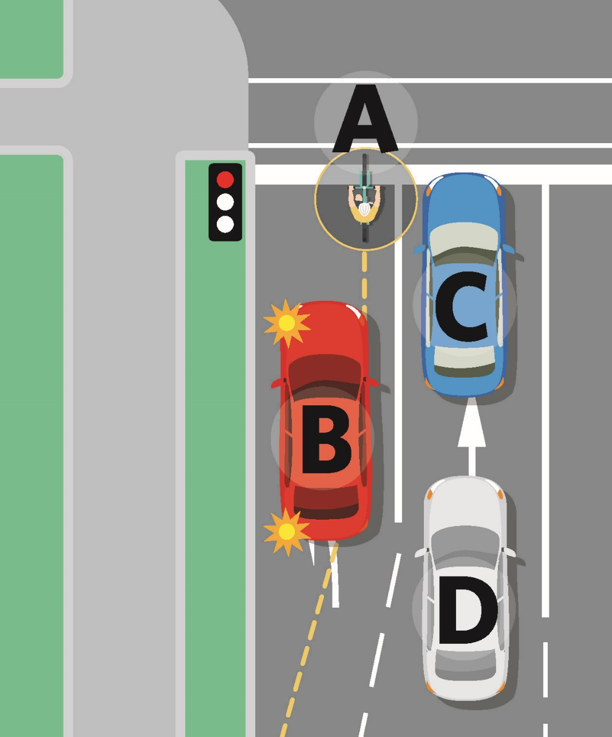
Figure A.
Under the proposed changes, the cyclist pictured (labelled A) will be able to travel straight ahead from the left turn lane with one left turning car (labelled B) instead of the lane with two cars (labelled C and D).

Proposal 6B). Allow cycles and transport devices to carefully pass slow-moving vehicles on the left, unless a motor vehicle is indicating a left turn
We propose that cyclists and transport device users will be allowed to pass slow-moving traffic on the left. Passing on the left is known as ‘undertaking’ and many cyclists do this already.
On the road, cycles and transport devices must ride as far left as practicable. ‘Undertaking’ allows them to maintain a safe, steady speed past slow, stop-start traffic, while avoiding travelling between motor vehicles.
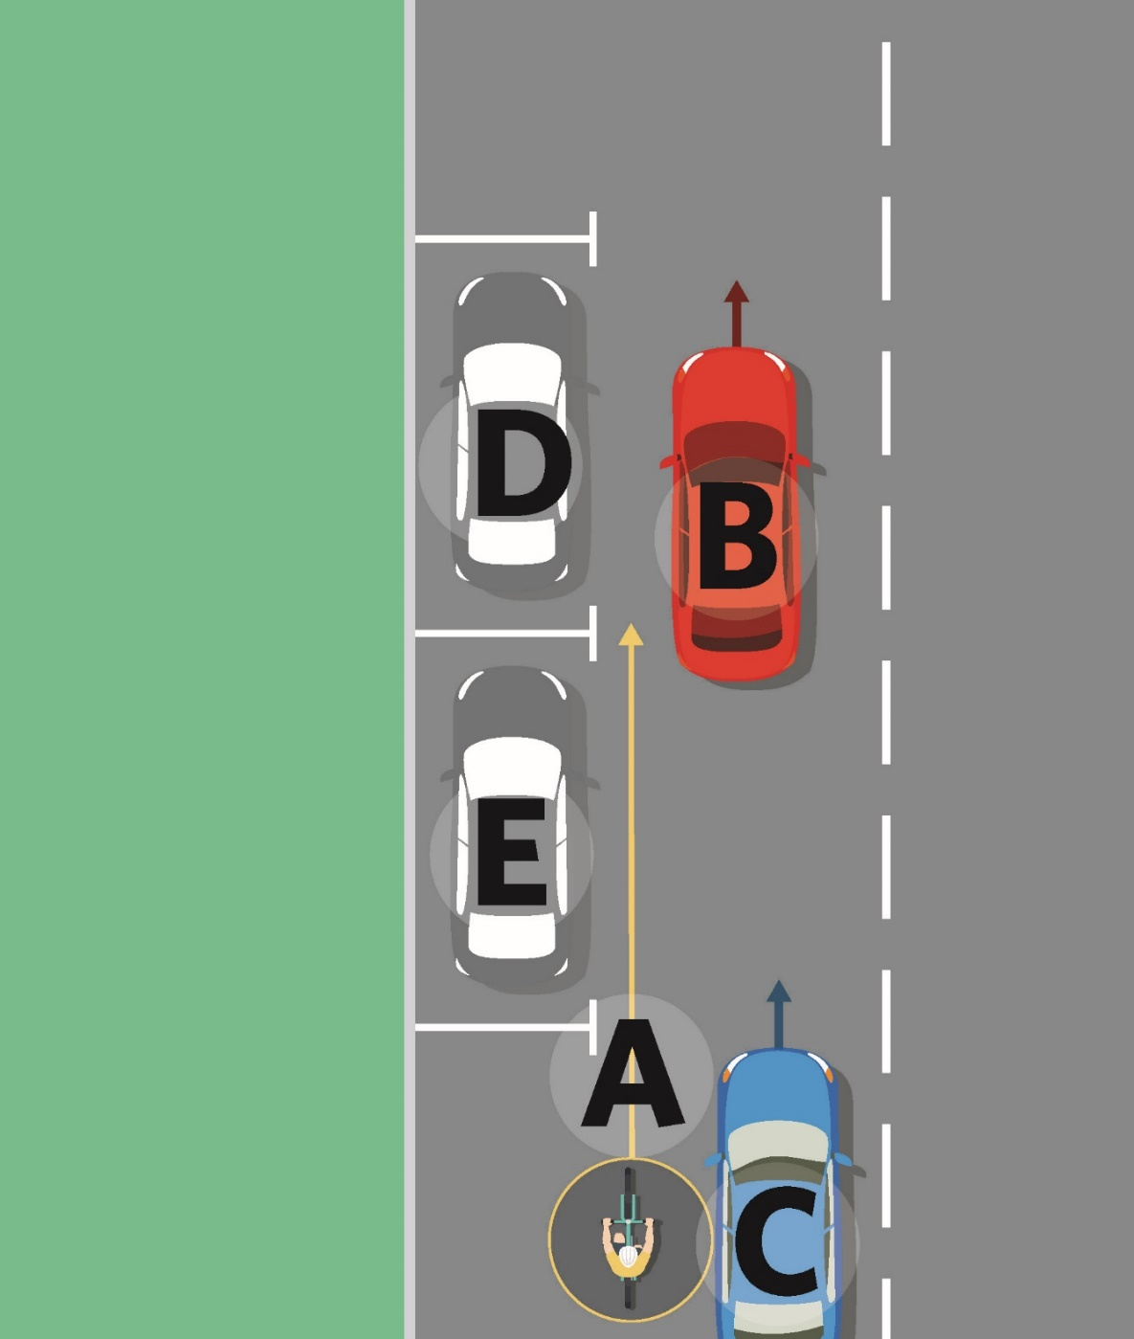
Figure B.
Under the proposed change, the cyclist pictured (labelled A) can pass slow-moving cars (labelled B and C) on the left. If the cyclist is passing slow-moving vehicles on the left and parked cars on the right (labelled D and E), the cyclist will need to pass carefully.

Proposal 6C). Give cycles and buses priority over turning traffic when they’re travelling through an intersection in a separated lane
We propose to clarify that turning traffic must give way to cycles, transport devices and buses when those users are travelling straight through an intersection in a separated lane, as pictured below in Figure C.
By separated lane, we mean a lane that is physically separated from other traffic lanes with the use of a device like a concrete barrier or planter box. These separated lanes are usually used by cycles, transport devices and buses.
This will clarify who has the right of way at intersections. Buses, cycles and transport devices can expect fewer delays as they do not have to wait for turning traffic. It is also expected to reduce risks for users of these modes as traffic is more likely to slow down before turning to check for cycles, buses or transport devices. Less risk and a faster commute may encourage the use of public transport, transport devices and cycling over private vehicles.

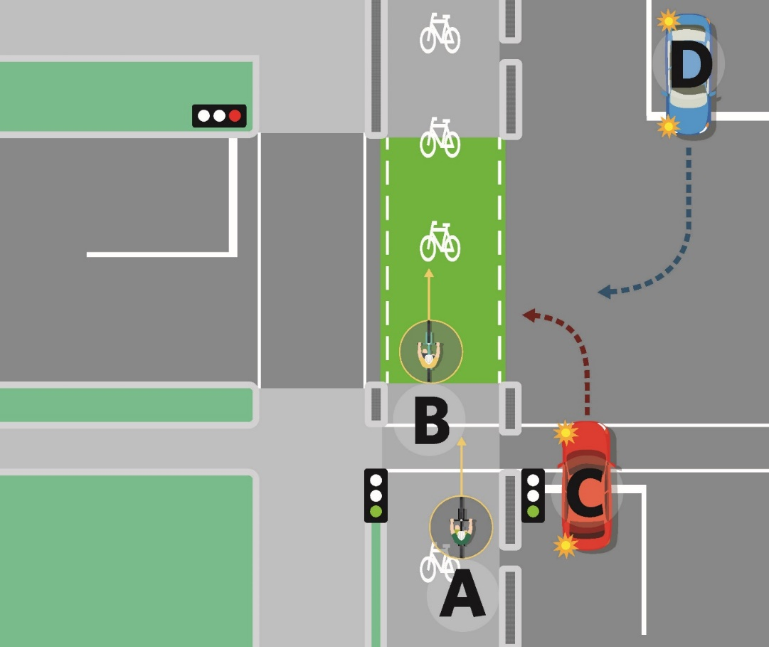

Figure C.
Under the proposed change, the cars pictured (labelled C and D) would need to give way to the cyclists travelling through the intersection (labelled A and B) before turning into the side road.

Proposal 6D). Give priority to footpath, shared path and cycle path users over turning traffic where the necessary traffic control devices are installed
Our proposed change will mean:

- People on the path will have priority over turning traffic when they’re crossing a side road, anywhere that minimum markings are installed.
- People on the path are treated consistently with other users going straight through, anywhere the appropriate traffic control devices are installed.

We propose that minimum markings be two white lines across the side road, as pictured below in Figure D. Our proposed change is expected to reduce delays for path users and make active modes more attractive.
Giving priority to footpath, shared path and cycle path users over turning traffic is expected to increase their safety and priority at intersections.

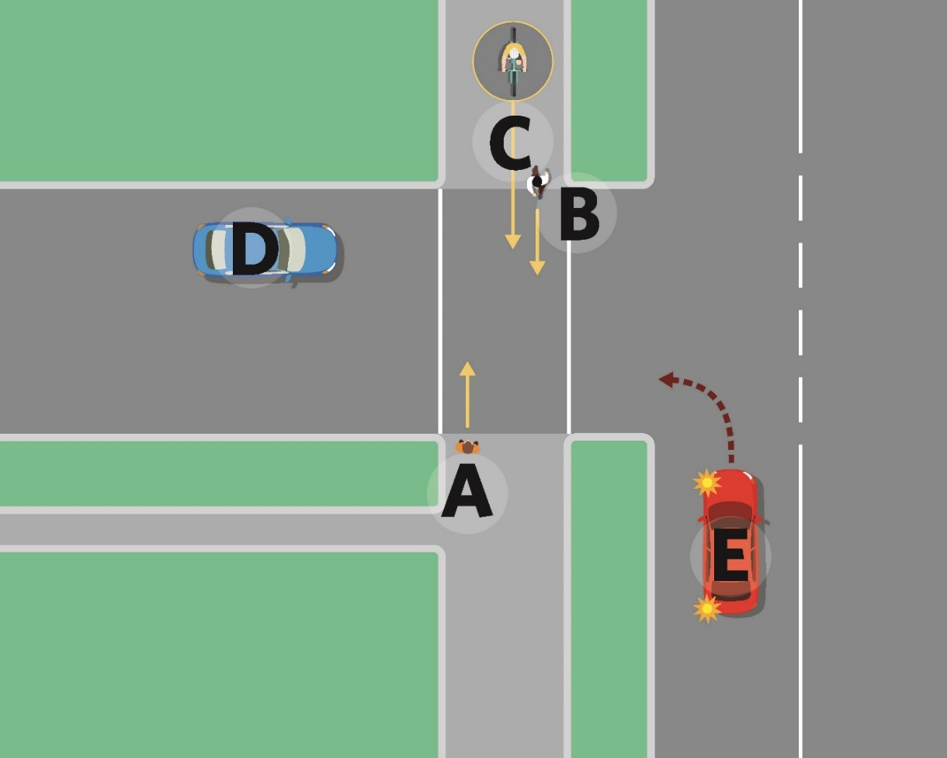
Figure D.
The pedestrians in the picture above (labelled A and B) are crossing the side road with white lines. We propose that these pedestrians would have right of way over turning traffic and other path users.
The cyclist (labelled as C) about to cross the side road, would also have right of way over turning traffic but would need to give way to the pedestrians also crossing the road.
The cars on the road (labelled D and E) will need to give way to the pedestrians and the cyclist crossing the road.

Proposal 7:
  - Mandate a minimum overtaking gap for motor vehicles overtaking cycles, transport devices, horses, pedestrians, and people using mobility devices on the road
Our proposed change will ensure drivers of motor vehicles pass at a safe distance when overtaking cyclists, horses, pedestrians and people using, transport devices and mobility devices on the road.
The minimum overtaking gap will be:

- 1 metre when the posted speed limit is 60km/h or less
- 1.5 metres when the posted speed limit is over 60km/h.
A mandatory minimum overtaking gap will:

- set a clear expectation about what a safe minimum passing distance is
- legitimise what’s currently a guideline
- raise awareness of this practice.

The proposed change is expected to decrease the number of incidents involving overtaking vehicles and vulnerable road users.

Proposal 8:
  - Clarify how road controlling authorities
can restrict parking on berms
Currently, to restrict parking on berms, local councils can introduce a bylaw:

- prohibiting parking in certain locations, and
- signposting the prohibition in those locations.

Different councils disagree on whether they need signage.
Our proposed change will remove the need for signage and clarify what’s needed for road controlling authorities to restrict parking on berms.
Road controlling authorities will be able to restrict parking on a berm or an area of berms by:

- passing a resolution, and
- registering the restriction with the NZ Transport Agency.

This means that if a road controlling authority believes that berm parking on a collection of streets is a safety issue, they’ll have the power to restrict berm parking in those spaces without using a sign.

Proposal 9:
  - Give buses priority when exiting bus stops
Under our proposed change, road users must give way when an urban bus on a scheduled public transport service:

- is leaving a signed bus stop, and
- has indicated for three seconds.

Our proposed change will apply on roads with a posted speed limit of 60km/h or less.
This will signal that public transport has priority in urban areas, as buses usually carry more people than cars.

We want to hear what you think
  - The next phase of the Rules development process is to consider your views, and the impact that the proposed changes would have on you.
You can find further information about these proposals in the Accessible Streets Overview (available at www.nzta.govt.nz/accessible-streets-consultation), which also includes a series of questions about the proposals. These questions are also provided in the online submission form, available at the above web address or by calling or writing to us.

Your submission is public information
We will use your submission to help us make the changes to the rules.
Please note that Waka Kotahi NZ Transport Agency (the Transport Agency) will publish a summary of submissions. If you do not want your name or any identifying information to be included in anything we publish (including because you believe your comments are commercially sensitive) please indicate this clearly in your submission.
Please note that your submission is also subject to the Official Information Act 1982 (OIA). This means that other people will be able to obtain copies of submissions by making a request under the OIA. If you think there are grounds for your information to be withheld under the OIA, please note this in your submission. We will take your reasons into account and may consult with you when responding to requests under the OIA.

You can make a submission in the following ways:

- Fill in the online survey: https://www.surveymonkey.com/r/MXTDZBC
(Please note that the online survey is based on questions in the full overview).

- Fill in the submission form, which contains the range of questions. The submission form is available online at www.nzta.govt.nz/accessible-streets-consultation and you can request a copy by emailing us (accessible.streets@nzta.govt.nz) or phoning our contact centre 0800 699 000

Please include the following information in your submission:
  - the title – Accessible Streets Regulatory Package 2020
  - your name
  - your job title and organisation’s name if applicable
  - your address or email address.

- Send your submission to us by email

Email us a letter, video response or survey to accessible.streets@nzta.govt.nz

- You can post us your submission to:

Accessible Streets Regulatory Package 2020
Transport System Policy Team
Free Post 65090
Waka Kotahi NZ Transport Agency
National Office
Private Bag 6995
Wellington 6141

Please note the deadline for submissions is 5pm on Wednesday 22nd April 2020.

