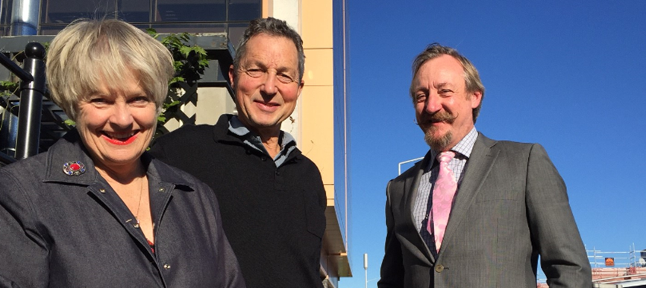
Ten years carpooling?
Leithfield and Waipara commuters tell us the secrets of their success

Maura Long, Paul Dickson and John Bown, the Christchurch city carpoolers from well north of the Waimakariri River
.

By Jim Harland, Regional Director, Southern, NZ Transport Agency
Jim Harland is leading a team working on short-term solutions to ease congestion and provide reliable journey times into Christchurch from the north. The Transport Agency’s longer term solutions to reducing northern peak congestion include the new Northern Arterial and the Western Belfast Bypass highway routes being built currently or starting construction later this year.
There are five of them: three from Leithfield and two from Waipara. They have been repeating the same workday behaviour since 2005, longer than some marriages, and are still happy to get together to explain how the well-oiled carpooling system they set up works 11 years down the track, before and after earthquakes.
Maura Long and Paul Dickson are neighbours in Waipara, John Bown, Myles Douglas-Withers and Andrew Kerry live in Leithfield. Maura, Paul and John all work in the Christchurch CBD, Andrew is on Stanmore Road and Myles is out at Middleton.
They used to meet up at Pukeko Junction, near Leithfield, at 6.45 am each morning to start work around 7.30 am. But since the earthquakes, with so many more people on the highway, they rendezvous at 6.15 am, arriving in Christchurch, 46 km away, around 7 am. Half an hour later and the journey between Leithfield and the city stretches to an hour-and-a-half.
At the end of the day, the three city workers are picked up at the corner of Tuam and Durham at 4.10 pm by Myles of Middleton, off to Stanmore Road for Andrew and home, riding the bow wave of the after-work hum back across the Waimakariri.
“There’s not much talk in the morning,” says Maura, the instigator of the whole thing, although the engineers sometimes fill the quiet with their particular brand of chit chat, she says.
Maura got the group going through an advert in the local newspaper. She didn’t get many responses but enough to start the ball rolling, at least with her grape-growing neighbour Paul. Work connections led to others joining.
“The more, the better,” believes John, who moved to New Zealand with his Kiwi wife in 2000 from the UK. He loves the sociability of carpooling. Keeping the number larger is part of the reason why he thinks they have lasted the distance. “You can’t be frustrated with other drivers and we’ve never had a speeding fine.”
“It’s cosy on cold days,” Maura says. “And in summer, we have all the windows open.”
There is always a lot more talk on the way home, she says, compared to the more subdued morning rides.
Myles originally joined the pool as a cost-saving exercise but now sees it as something that improves his life and reduces stress. “I really enjoy not driving four days in every five. It's like having your own taxi service and the social side is great. We have some hilarious discussions and generally put the world to rights during our trips to and fro."
The earthquakes provided a disruption but not for long. They were soon back to their various jobs, some in different places, but still with the carpool. Heading away from the damaged, cordoned city each day to the less-shaken Waipara and Leithfield was a great relief, Maura says.
The North Canterbury communities are small and everyone helps out, as the carpool group does too – volunteering for a show-jumping event or borrowing a trailer for a day. A village within a village
The advantages – not just fuel savings
Paul says that when diesel doubled in price from 56 cents a litre, the sharing of rides became a no-brainer. Carpooling allows them to be dropped off where it suits them, but it also imposes a disciplined approach to the much-talked about life-work balance: Just after 4 pm each day, regardless of whatever is happening in the office, you have to be out that door, John says. You cannot keep your carpooling associates waiting and there is no back-up bus to get you home.
Each of the five uses their car on one day of the week, driving the others, with Myles doing the last jump from the city to Middleton and back to town in the afternoon. At Pukeko Junction, they go their separate ways – another 19km for Paul and Maura, a shorter distance for the Leithfielders.
The make-up of the five has changed over the years. Paul’s son used to ride with them as a young teenager, sitting in the middle. Over the years, he grew larger but continued to be delegated his middle seat spot until he outgrew the whole thing around age 18. Another carpooler, Marian, of Amberley, retired from city employment, prompting the hire of a stretch limo for that particular day’s journey.
Maura was aware of one other group of Pukeko Junction carpoolers over summer, but they appear to be hibernating or back to individual cars for winter.
- If you are interested in trying out carpooling – go to www.letscarpool.govt.nz or place an advert in your local community paper or on a noticeboard. It might not be a five days a week habit as it is for Paul, Maura, John, Myles and Andrew, but even a couple of days a week will help cut the number of cars heading into and out of Christchurch from the north and save you money.
*This story was originally published in the North Canterbury News 16 June, 2016. This is their web page and facebook site.

