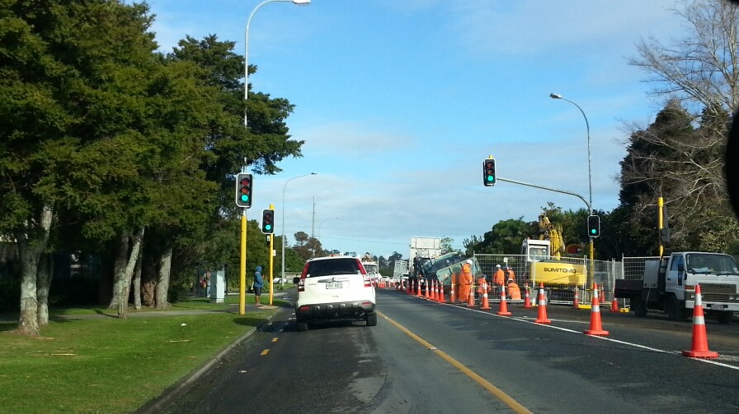
Document name
Date: 25 and 26 January 2018
Venue: Novotel Auckland Airport,
Ray Emery Drive, Auckland
Advanced Traffic Management Planning (ATMP) workshop

Advanced Traffic Management Planning (ATMP) workshop

About the ATMP workshop
The CoPTTM Governance Group (CGG) prioritised the development of an advanced planning workshop for TMP designers, reviewers and approvers.
NZTA has developed the workshop and introduced a new STMS qualification of Advanced Traffic Management Planner (STMS-AP). The issuing of this qualification is dependent on the attendees completing the workshop and a back at work assessment.
The 2-day workshop focusses on planning the TTM for a worksite, with an emphasis on complex situations. Note: Complex means a major change to road user conditions, the sort that comes with large projects or where large traffic flows need to be managed.
The workshop has been designed with the following roles in mind:
- STMS involved in developing TTM documents for complex sites
- Project planners
- TMCs and other TMP approvers
- Auditors.

What it covers
The workshop covers the following steps:
- Identifying matters to be addressed
- Planning the closure(s)
- Planning for other considerations
- Planning for the road users
- Resolving conflicts
- Developing the TMP
- Submitting the TMP for approval
- Reviewing approval documentation (eg TMP, consent to work, other authorisations)
- Pre-implementation of the TMP
- Implementing the TMP
- Completing a TTM review.
During the workshop drawing standards for a TMD will be outlined, including an introduction to different drawing options (eg Invarion, CAD, MSOffice). Follow-up training sessions can be arranged with practitioners for each of the site drawing options. A list of these practitioners will be made available during the workshop.

Eligibility for attendance
To be eligible, attendee’s must:
- Hold a current STMS warrant
- Be competent with word processing to an intermediate level (add/amend tables, format text etc.)
- Be able to navigate CoPTTM to find required information
- Be able to clearly express an idea in writing (completion of a detailed TMP form).

ATMP Registration Form
ATMP Registration Form
9 and 10 March 2017 at the Commodore Hotel, Memorial Ave, Christchurch
Name:
Organisation:
Address:
Email:
Telephone:
Any special requirements (eg dietary needs, limited mobility)

- Please advise all interested parties to contact Kim Laurenson (copttm.quals@nzta.govt.nz) to reserve a place at the workshop and to receive joining instructions. This workshop will be restricted to 15 attendees.
- The charge for the workshop is $1,250 plus GST per person.
- Assessment will either be by submission of an approved Full form TMP that has been successfully implemented on a road network or by completion of an acceptable Full form TMP during the workshop.
- Where an attendee does not regularly submit the Full form TMP for approval on the network and does not satisfactorily complete a Full form TMP during the workshop, a charge for a follow-up competency assessment on a Full form TMP will apply. This fee covers the review of your plan, feedback and checking of minor alterations.
- Lunches are provided but attendees are responsible for their own travel and accommodation costs plus evening meals.
- If there is a need to discuss the workshop, please contact either:
  - neil@ngtc.co.nz, or
  - tony@stellaassociates.co.nz or
  - stuart.fraser@nzta.govt.nz,

