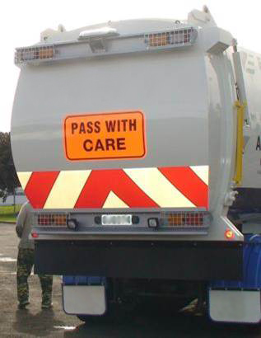
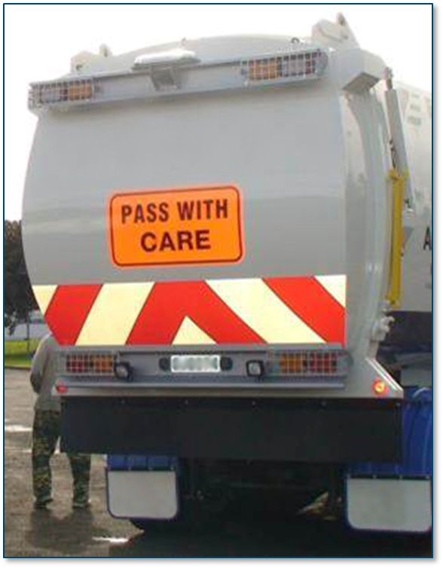Document name
Organised on demand
(requires a minimum of 10 participants)
Kerbside Collections Traffic Leader (KCTL) Train the Trainer workshop workshop

Kerbside Collections Traffic Leader (KCTL) Train the Trainer workshop

About the KCTL Train the Trainer workshop
This one-day workshop is designed to refresh participants on the content of the KCTL workshop with a focus on the development of training skills. These are taught, modelled, coached and tested during the workshop.
Prior to attending the workshop, participants must have a sound understanding of kerbside collection operations and hold or be working towards the New Zealand Certificate in Adult and Tertiary Teaching (Level 5) or similar qualification.

Who should attend
Persons chosen to be KCTL trainers within their organisation.
Persons wanting to become a KCTL trainer on a commercial basis (requires close contact with client companies).

Workshop cost
The cost is $360 + GST for the one-day workshop.
This covers all notes, registration, instructions, training material, morning and afternoon tea and lunch.

KCTL Train the Trainer Registration Form
Send completed registration form to copttm.quals@nzta.govt.nz

KCTL TTT Registration Form
Name:
Location:
Organisation:
Address:
Email:
Telephone:
Any special requirements | (eg dietary needs, limited mobility)

- If there is a need to discuss the workshop, please contact either:
  - neil@ngtc.co.nz or
  - tony@stellaassociates.co.nz or
  - stuart.fraser@nzta.govt.nz

