

Part 8 of the Traffic Control Devices Manual (TCD Manual)
Code of Practice for Temporary Traffic Management (CoPTTM)
(CoPTTM) - (SP/M/010)
Fourth Edition – Technical Note Changes to B3 High visibility garments

Prepared By: | Stuart Fraser for National Traffic and Safety Manager
Date of Issue: | 12 September 2016

Circulation | Regional Operations Managers, holders of the Code of Practice for Temporary Traffic Management and NZTA website. Please forward to your consultants and contractors
Objective | To update the July 2015 version of the Fourth Edition of the CoPTTM.
Effective date | 1 October 2016
Status | This document is a guideline for use by the roading industry, road controlling authorities, network utility operators and event holders.
Implications | The changes are as a result of the:  - Introduction of the option to have a cross configuration on the back of high visibility garments (excluding the STMS garment)  - Removal of requirements for TC vest  - Feedback from garment testers.
Reminder for all holders | It is important to keep holders of our documents up to date.
Additional copies | These may be downloaded from NZTA’s website, free of charge or purchased direct from our distributor either via the website, or directly to NZ Print, PO Box 2491, Wellington, 6140

Key to changes | Additional text | Highlighted in yellow
Key to changes | Deleted text | Red strike through
Key to changes | Comments about the change | Italic text

Reference in 4th Edition | Change
B3.1.2 Retro-reflectivity | Add additional paragraphs  The retro-reflective material must comply with the specification for Class ‘R’ material as noted in Section 3 and Table 3.2 of AS/NZS1906.4:2010.  Retroreflective orange red material for STMS panels must comply with the colour specification for Class F background material as noted in Clause B3.1.1 and exhibit a level of retro-reflectivity no less than 60 CIL/m2 at entrance angle 5.0 degrees and observation angle 0.2 degrees.  Note: Rainfall performance and luminance factor tests are not required for the retroreflective panels.
B3.2 Logos | Amendment to 4th paragraph  Where required for related safety reasons a fabrics technical recognition I.D. may be added in an area not exceeding 30mm x 30mm (900mm2) may be added to the front to the upper front right side of a garment.  Amendment to 5th paragraph  A manufacturers label to a maximum size of 50mm x 20mm may be sewn or printed on non-high visibility non-compliant material on the lower sleeve or leg.
B3.3 Garment compliance | Amendment to 2nd paragraph  All retro-reflective material applied to garments, including extra small size garments complying with subsection B3.4 Garment design must be in strips 50±1mm wide.no less than 50mm wide. Hoops must completely encircle the torso with no breaks except for the permitted front opening. Braces or the rear cross configuration must meet at the top of the shoulder and at the hoops.
B3.4.1 Sleeveless vest | Add new heading  B3.4.1.1 Sleeveless vest requirements  Amendment to 2nd bullet point  - the design must include a shirt tail back that is 150mm 150±5mm longer than the front  Amendment to 6th bullet point  a permitted front opening to accommodate a zip fastener or similar closing device may be no wider than 25mm. Zip colour may be black but a colour matching the garment colour is preferred. Any buttons, domes or similar closure devices on any compliant high visibility must match the colour of the garment (matching colour need not be compliant)  Add additional bullet points 10 and 11  - An optional cross configuration permitted for the back only must meet the front braces at the shoulder and the belt at the back vertically below the shoulder position to comply with the pattern in Figure 1.  - The optional retroreflective cross configuration on the back of a garment is not permitted for STMS garments.

Replace Figure 1: Sleeveless vest (size small)
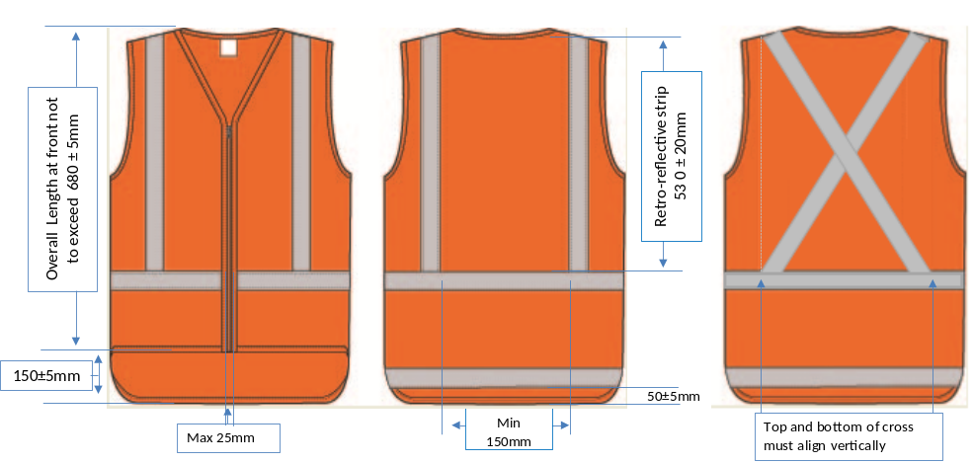
Figure 1: Sleeveless vest (size small).
Add new subsection
B3.4.1.2 Application of cross configuration on back of high visibility garment
To date NZTA has seen little evidence that supports any improvements in safety by using the cross configuration on the back of high visibility garments rather than the belt and braces configuration.
Despite this lack of evidence NZTA is allowing the use of an optional cross configuration on the back of high visibility garments.
The optional retroreflective cross configuration on the back of a garment is not permitted for STMS garments.
Contractors will be able to use this optional cross configuration for their staff but will not be able to require subcontractors or any visitors to site to have the cross configuration rather than the belt and braces configuration on the back of their high visibility garments.
The effective date for the introduction of the cross configuration will be 1 October 2016.
B3.4.2 Identifying vests for STMS and TC | Remove reference to TC vest from heading  Remove subheading for STMS sleeveless vest  B3.4.2.1 STMS sleeveless vest  Amendment to 2nd bullet point  - a retro-reflective fluorescent orange red panel measuring 150mm x 150mm (±10mm) must be placed on the upper left front of the garment. This panel may cover some of the retro-reflective element at the front and replaces the permitted logo area. Refer to subsection B3.2 Logos

Relocated Figure 2 to be closer to STMS vest requirements
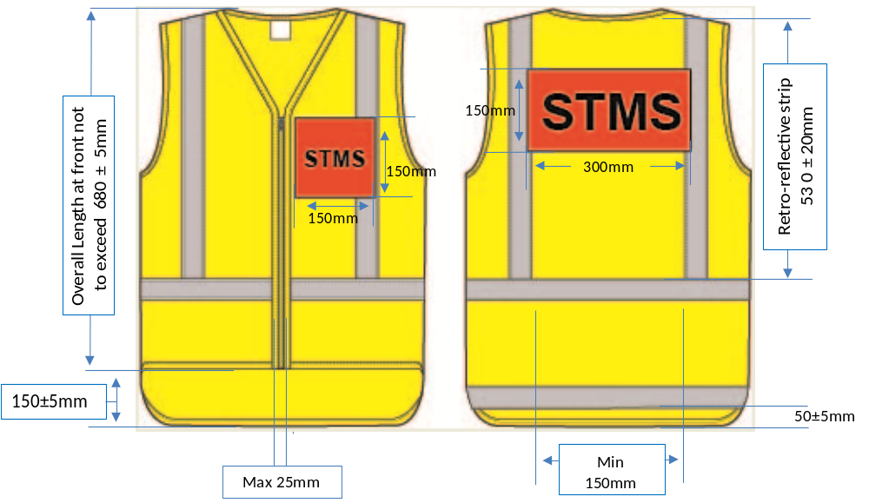

Figure 2: STMS sleeveless vest (size small).
Amendment to dimensions in table
The legend, STMS, must be displayed on the back and front left orange red panels in the following manner:
 | Colour |  | Black
 | Font |  | Helvetica Bold
 | Letter height | Front | 50mm 50±2mm
 | Letter height | Back | 100mm 100±2mm
Add additional bullet point after table
The optional retroreflective cross configuration on the back of a garment is not permitted for STMS garments.
B3.4.2.2 TC sleeveless vest
Remove requirements for TC vest
B3.4.2.2 TC sleeveless vest
In circumstances where an STMS is supervising a number of sites a TC will assume control of the TTM at the worksite.
Retroreflective fluorescent yellow green panels located on the standard Class F (or Class NF) orange high visibility garment will identify the TC. These panels must only be displayed when responsibility for the site is delegated to the TC.
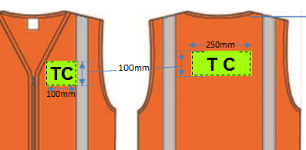
Note: If the above TC panels are permanently affixed to the garment it may only be donned when the responsibility for the site is delegated to the TC.
Removable TC designation panels will be securely attached to the garment with the addition of either clear pockets or hook and loop fastening sewn onto the front left and centre back of the garment:
- on the upper left front of the garment a panel measuring 100mm x 100mm (±5mm) with the letters T C in 75mm helvetica bold. This panel may cover some of the retro-reflective element at the front and the compliant 7500mm2 logo area
- on the upper centre back of the garment, between the retro-reflective braces a panel measuring 100mm x 250mm (±5mm) with the letters T C in 75mm helvetica bold. This panel may cover some of the retro-reflective elements at the back
- each panel may be reversible; with the back of each panel being compliant Class F (or Class NF) orange garment material such that when reversed the garment will become a standard orange garment
- the orange reverse side of the front TC panel may include the 7500mm2 logo that would appear on other standard garments.
B3.4.3 Long-sleeve coat | Amendment to 2nd bullet point  - the minimum qualifying area measurement of background high visibility material for the recognised small size coat not covered by retro-reflective material or printing must be measured in the same way as for the sleeveless vest specified in subsection B3.4.1 Sleeveless vest except that the measurement rectangle must extend a minimum of 830mm at the front and back. Sleeves are not included in this area  Add additional bullet point after bullet point 5  - compliant retro-reflective material must be positioned to comply with the pattern in Figure 3  - An optional cross configuration permitted for the back only must meet the front braces at the shoulder and the belt at the back vertically below the shoulder position to comply with the pattern in Figure 3
B3.4.3 Long-sleeve coat | Replace Figure 3: Long sleeve coat (size small).  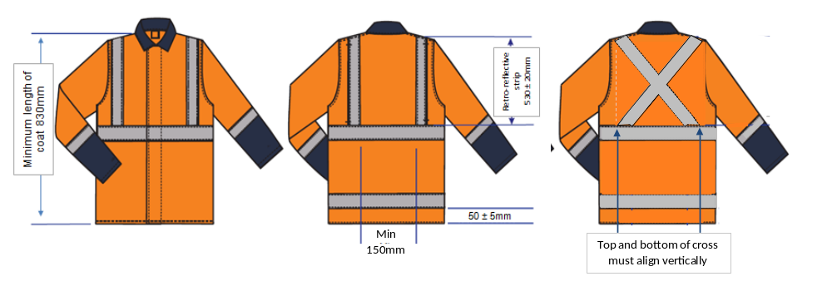  Figure 3: Long sleeve coat (size small).
B3.4.3 Long-sleeve coat | Amendment to 8th bullet point  non-compliant high visibility colours may not be located within the qualifying torso area as trim or pocket flaps. Collar material may be a non-compliant colour but any such material that covers qualifying high visibility material in its normal worn position must be deducted from the qualifying torso area

B3.4.4 Overall garment | Amendment to 2nd bullet point  - the minimum qualifying area measurement of background high visibility material for the recognised small size garment not covered by retro-reflective material or printing must be measured in the same way as for the sleeveless vest specified in subsection B3.4.1 Sleeveless vest except that the measurement rectangle must be extended to a point on the leg above the knee. Sleeves are not included in this area
B3.4.4 Overall garment | Replace Figure 4: Overall garment (size small).  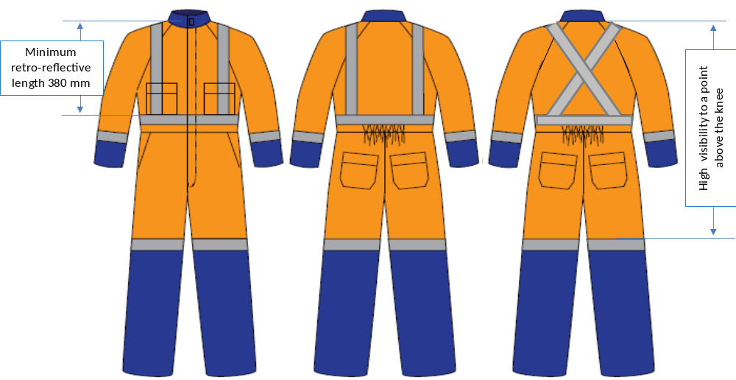  Figure 4: Overall garment (size small).
B3.4.4 Overall garment | Add additional bullet point after 5th bullet point  - compliant retro-reflective material on the torso must be positioned to comply with the pattern in Figure 4.  - An optional cross configuration permitted for the back only must meet the front braces at the shoulder and the belt at the back vertically below the shoulder position to comply with the pattern in Figure 4  Amendment to 7th bullet point  non-compliant high visibility colours may not be located within the qualifying torso area as trim or pocket flaps. Collar material may be a non-compliant colour but any such material that covers qualifying high visibility material in its normal worn position must be deducted from the qualifying torso area
B3.4.5 Miscellaneous garments | Delete 1st bullet point and replace with new bullet point  - such garment is specifically designed to comply with subsection B3.4.1 Sleeveless vest high visibility background material and minimum area including the shirt tail complies with subsection B3.4.1 Sleeveless vest  - the minimum qualifying area measurement of background high visibility material for the recognised small size garment not covered by retro-reflective material or printing must be:  - Front of garment 0.21m²  - Rear of garment including the 150mm shirt tail 0.27m²  Note: Sleeves are not included in this area  Add additional bullet point after 2nd bullet point  - the configuration of compliant retro-reflective material complies with the configuration specified in subsection B3.4.1 Sleeveless vest including a strip on the shirt tail at the back  - An optional cross configuration permitted for the back only must meet the front braces at the shoulder and the belt at the back vertically below the shoulder position to comply with the pattern in Figure 5  Amendment to 5th bullet point  - the area of compliant high visibility background material is measured from material that will be visible when the garment is worn in its normal manner. Note: Wearers should be aware that such Such garments will not comply when tucked into trouser type garments  Amendment to 6th bullet point  - if the garment has a collar this may be a non high visibility colour provided any high visibility colour under the collar worn in its normal position is deducted from the qualifying area.  - non-compliant colours may not be located within the qualifying torso area as trim or pocket flaps. Collar material may be a non-compliant colour but any such material that covers qualifying high visibility material in its normal worn position must be deducted from the qualifying torso area.
Replace Figure 5: Miscellaneous garment size small Long Sleeved Polo
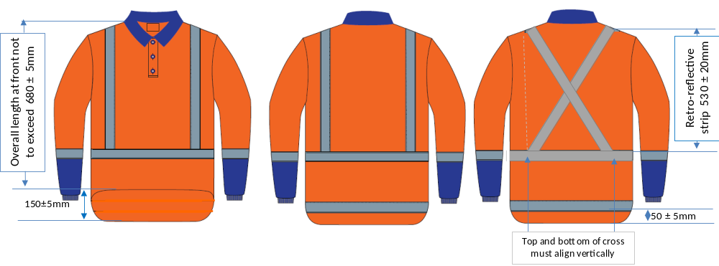
Figure 5: Miscellaneous garment size small Long Sleeved Polo.

