Single stage business case guideline
[AUTHOR]
[DATE]
VERSION
Document subtitle

Introduction if required et etur sandamus, non consequatum facea aut iur maionse quaepro il magnisquam qui blamet et omnisto exeribus demoluptur? Usame eos volorest, nullor raestium voluptate lam, ullitat iumque quiaeprovid ut

Copyright information
This publication is copyright © NZ Transport Agency. Material in it may be reproduced for personal or in-house use without formal permission or charge, provided suitable acknowledgement is made to this publication and the NZ Transport Agency as the source. Requests and enquiries about the reproduction of material in this publication for any other purpose should be made to:
Manager, Information
NZ Transport Agency
Private Bag 6995
Wellington 6141
The permission to reproduce material in this publication does not extend to any material for which the copyright is identified as being held by a third party. Authorisation to reproduce material belonging to a third party must be obtained from the copyright holder(s) concerned.

Disclaimer
The NZ Transport Agency has endeavoured to ensure material in this document is technically accurate and reflects legal requirements. However, the document does not override governing legislation. The NZ Transport Agency does not accept liability for any consequences arising from the use of this document. If the user of this document is unsure whether the material is correct, they should refer directly to the relevant legislation and contact the NZ Transport Agency.

More information
NZ Transport Agency
Published [month and year]
ISBN [number]
If you have further queries, call our contact centre on 0800 699 000 or write to us:
NZ Transport Agency
Private Bag 6995
Wellington 6141
This document is available on the NZ Transport Agency’s website at www.nzta.govt.nz

Contents

Single stage business case guideline 1
Contents 3
Executive summary 5
Funding application to proceed with single stage business case 6
Strategic context 7
Status of programme delivery 7
Strategic assessment 8
Project plan 8
Next steps / recommendation 9
Single stage business case 10
Recap of single stage business case 10
Review 10
Status of programme delivery from PBC 11
Option development 11
Short list development 11
Recommended option assessment 12
Appendix A – Investment logic/Outcome map 13

This guideline outlines the information and analysis which should be considered for an activity level single stage business case. The activity will either be as part of a programme (from a programme business case (PBC)) or following on directly from a strategic case. From either phase, you will review and confirm the strategic context and strategic assessment and modify as appropriate (outlined further throughout this guidance). This case will then look at optioneering at the activity level and work to conclude a recommended outcome to achieve the benefits required.
The primary purpose of a single stage business case is to provide decision-makers with an early indication of the recommended investment. The level of effort required to develop a business case should be proportionate to the complexity and risk of the problem and the likely scale of the potential investment. This guidance has deliberately been given at a fairly high level to ensure effective thinking is used to gain the most appropriate business case for your activity rather than following a check box process. If there is any uncertainty, speak with your business case advisor throughout the process.
A single stage business case (SSBC) merges option identification and detailed analysis in one phase of the Business Case Approach (BCA). To summarise, a single stage business case should:
- Review the strategic assessment and strategic context from the previous phase, and use evidence to confirm, modifying it as appropriate and ensuring the problems identified and the outcomes sought have not significantly changed
- Evaluate a range of options to identify a recommended approach that represents value for money
- Provide quantifiable evidence that the recommended option is the best way to respond to the problem and deliver the expected benefits
- Identify and calculate costs, risks and benefits of the recommended option, including details of the financial, commercial and management aspects of the activity
- Identify measures for monitoring and evaluating the performance of the investment as part of benefit realisation

A great way to get this started is to whiteboard your ideas before putting any business case together. Jot down ideas around the problems, causes, local area and wider context, etc and what you will look into in greater detail, and why, in your business case. Consider the logic flow through context, evidence, long list to short list and then final option. This thinking will then cover the basis of the scope of your SSBC, and you should discuss this with your relevant advisor or stakeholders.
The Highways information portal website has more information on the business case approach that will provide further information to what is in this guideline. Be in touch with the Design Practice and Solutions team in System Design and Delivery early on to ensure best practice throughout your business case and to minimise possible rework or missed points.
Single stage business case process (seek advice from Design Practice and Solutions, Partnership Investments or Investment and Finance throughout as required)
  - Approval of strategic case or programme business case
  - Scoping of single stage business case
  - Funding application to undertake single stage business case
  - Production of single stage business case
  - Submission of single stage business case for approval

Executive summary
The executive summary is arguably the most important part of the document, and likely to be what decision makers read to gain insight into the business case.
Anyone should read the summary and be able to understand:

- The strategic context and fit of the proposed investment
- The strategic assessment, case for change and the need for investment
- What the next steps are and what is being recommended and asked for in this business case phase

Funding application to proceed with single stage business case
This funding application is the information you need to provide to decision makers to secure funding to deliver a single stage business case and will clearly be linked to your SSBC scoping document. This section should be used when the activity follows on from an existing programme business case. As this is an application to decision makers rather than the business case itself at this point, it will usually be less in-depth than your ‘single stage business case section’ that follows.
If your activity does not come from a supported programme business case, your activity initiation should start with a strategic case which will include funding approval via Strategy, Policy and Planning. However, a check in and review to see if things are still correct or need updating is appropriate if some time has passed, and this section of this document should still be used, albeit can be modified to fit your project requirements.
Consider building a one page summary of this information to link back to the PBC A3 summary this activity has come from that you can build on as you progress this business case. This is a good way to show your thinking around what this activity involves and how it sits in the bigger picture.

Example/ guide:
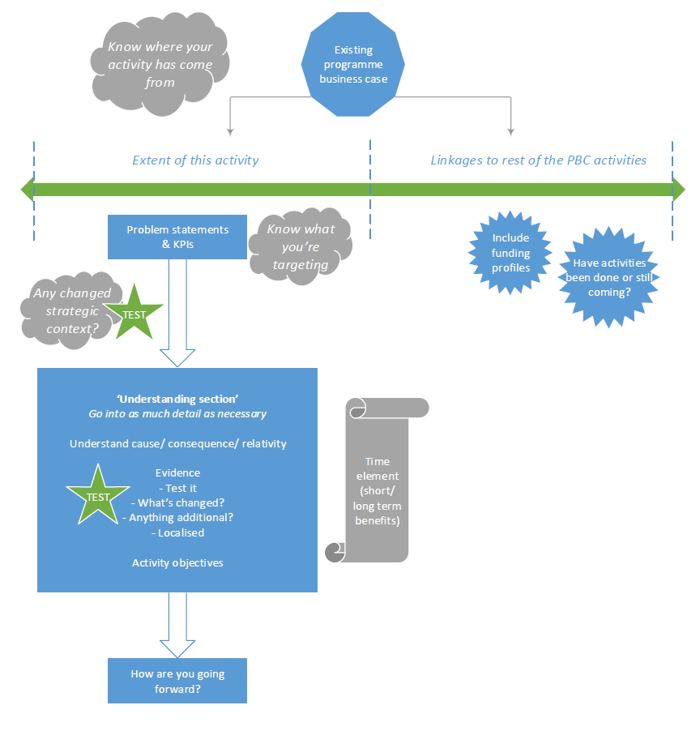

Strategic context
The purpose of the strategic context is to set out the overall big picture view of how this activity delivers the policy priorities of NZ Inc, Government Policy Statement, Long Term Strategic View, NZ Transport Agency and relevant Design Portfolio, as well as considering relevant partner organisations’ strategies and transport plans, etc. Consider relevance and influence, not just the existence of strategies.

Status of programme delivery
If the activity has come from an approved programme business case, include your programme linkages. Consider things like:
- The main points of the PBC to ensure we are still on the same track
- How the activity helps to deliver the whole programme
- Why the activity is being promoted through an SSBC at this particular time
- What has changed (if anything) since the PBC was approved

Use this section to set out the scope of the evidence and focus on the detail around the activity within the whole PBC corridor/area.

Strategic assessment
Things to consider in this section (use sub headings as appropriate):
- Review and set out the problems, benefits and investment objectives that were set in the previous business case phase at more detail at this activity level. An investment logic map (ILM) (or revision of an ILM) should be considered where the activity is complex or a long period of time has passed since the PBC
- Customer insights work and how it relates to the problems, benefits and investment objectives should also be included. Work with the Customer Experience and Behaviour team if you are unsure
- Investment objectives should have been drafted in the previous phase; now is the time to review them with relevant stakeholders to ensure you know what is being targeted in this business case and ensure they are suitable at the activity level (rather than at corridor level)
- Evidence gathering that relates to the activity area to confirm the problems (cause and consequence), or narrowing your evidence base to activity level
- The contribution that this activity makes to the recommended programme identified in the PBC and the linkages to any other activities that have/will come from the PBC

Project plan
This section will be the outline of your business case deliverables that allows the decision maker to really get a grasp of what the cost of the SSBC will cover. Discuss this as you develop it with relevant advisors and stakeholders.
Consider the following items:
- What will be in / out of scope, what now needs to be completed from past phases
- Ensure you have all the necessary information to fill in TIO/Planview fields
- SM014 cost estimation requirements
- Technical standards and single stage technical requirements
- Risks (identification, ownership and valuation), constraints, assumptions and mitigation
- Strategic fit and effectiveness / results alignment and cost benefit appraisal
- Procurement approach
  - Consultation requirements
  - Programme management and expectations
  - Discuss requirements or queries with the Procurement team
- People
  - Governance
  - Sponsor
  - Internal/external stakeholders
  - Community, industry, iwi
- Communications and engagement (internal and external)
  - Objectives
  - Audiences and involvement
    - See also ‘people’ above
  - Key messages
  - Communication tools and channels
- Process steps and hold points
- Key milestones
- Roles, responsibilities and collaboration
- Deliverables (ie long list report, short list report, MCA, consultation, consenting, property, procurement, risks, peer reviews, etc)

Prioritisation (within the NZ Transport Agency, NLTP or design portfolio) as relevant to your project and depending how far along the process it currently is, if it’s from an existing programme, etc. This is also the place to consider how you will look to be added to the NLTP if that is relevant.

Next steps / recommendation
Be clear about what this funding application is asking for, including costs to complete the SSBC (and any activity cost and BCR estimates you have from the PBC).

Single stage business case
This section of the business case is to be completed in detail at the activity level once the funding application has been approved to proceed or when continuing directly from a strategic case. It is expected that this would be done directly following the completion and approval of the previous section. If it is, the previous section can be used as a preface/scope to this single stage business case. If there is a time lapse between the previous phase and this single stage being completed or significant context change, a check in and update is expected to be completed. The aim is not to redo work but rather to ensure it is up to date and fit for purpose.
If there is any uncertainty of which section should be used or not, think of the logical sequence of information that a decision maker would need to follow through your business case phases, or check in with your business case advisor in the Design Practice and Solutions team.

Recap of single stage business case
A single stage business case (SSBC) merges option identification and detailed analysis in one phase of the business case approach. An SSBC is most often used for straight forward business cases. An indicative and/or programme business case is expected to be used for more complex business cases (see flow diagram above).
To summarise, a single stage should:
- review and evidentially confirm the strategic assessment and strategic context, modifying it as appropriate (remember, you can incorporate what you have already done in the previous phase/section as relevant)
- identify and evaluate a range of options to identify a recommended option that represents value for money
- provide robust, and ideally quantifiable, evidence that the recommended option is the best way to respond to the problem and deliver the expected benefits
- calculate the costs, risks and benefits of the recommended option, including details of the financial, commercial and management aspects of the activity. Reasonably mitigate, to the extent possible, cost and scope variations through implementation
- identify measures for monitoring the performance of the investment

Review
Review the following to ensure they are still correct and up to date or if any changes need to be made. (This is where to decide whether it’s best to incorporate the work you have just done above, or revisit.)
- Problem statements
- Benefits of investment and objectives
- Status of the evidence base

Status of programme delivery from PBC
If this activity has come from a programme business case, include your programme linkages. This ties in with the A3 summary you may have already begun putting together from the front end of this document.
Consider things like:
- Programme overview
- Programme outcomes and what has already been achieved / what will this activity help to achieve
- Programme assumptions – eg cost estimates, benefit pooling, component BCR estimate
- Programme performance and review, including latest programme BCR
- Programme investment assessment

Option development
The purpose of option development is to assess a wide range of possible solutions to find the best way to deliver the outcomes sought.
If a programme business case has not been undertaken, your option development should cover the full intervention hierarchy and spectrum of strategic alternatives and options that can respond to the problems, benefits and outcomes set in your strategic assessment.
When coming from a programme business case, your option development will focus at an activity level to deliver on the supported programme of work.
Your optioneering should cover (use subheadings as appropriate):
- Long list intervention development and analysis (MCA against objectives may assist)
- Analysis of long list interventions into options (indicative costs)
- (Qualitative) multi-criteria analysis of long list options (investment objectives finalised)
- Short list option development

Short list development
The next part of this section of option development (now at a short list) should cover (use subheadings as appropriate):
- Short list option analysis (detailed)
- (Quantitative) multi-criteria analysis of short list options
- Completion of the outcomes table
- Recommended option
Consider how your multi criteria analysis (MCA) fits into the end to end project development - if consenting represents a significant risk, should it be documented to an RMA standard and utilise experts early to ensure continuity for assessment of environmental effects purposes later on.
This is the time to also get your check in and interim IQA to ensure this business case is on track and the likely recommended option is in line with relevant priorities.

Recommended option assessment
Once you have come to a conclusion with your recommended option, this part of the business case should cover your technical detail (use subheadings as appropriate). Complete the work to a fit for purpose effort keeping in mind the size and scale of your problem and project. Ensure enough detail is provided to reasonably mitigate the potential for future cost and scope variations, and for decision makers to be confident of the recommendation and way forward.
- Analysis of recommended option
  - costs
  - risks, mitigation
  - benefits
  - investment objectives, measures and baselines all finalised
  - finalised results alignment and cost benefit appraisal
  - indicative design
  - evidence this is the best option to deliver benefits and value for money
- Detail to provide confidence moving forward
  - Financial case
  - Commercial case
  - Management case
  - Consenting strategy, etc
  - Monitoring plan (benefit realisation)

Consider finalising your activity level A3 summary with your recommended option. Include how this links back to your programme business case. Or, even if this activity has not come from a PBC, you may find it useful going through support and approval processes having your recommended option and business case set out in an easy to follow format like this.

Appendix A – Investment logic/Outcome map
Whether you have undergone an investment logic mapping session or not, include a ‘map’ that shows your problems, benefits, investment objectives, measures, baselines, expected outcomes and how they link together.

Add further appendices as required.

