Tenancy Tribunal Rent History Statement - Instructions
- Open up the Real Estate Contract in SAP to source the details.
- Open up Excel Tenancy Tribunal Template spreadsheet
- Insert Tenant and Tenant Address Details into the spreadsheet (copy and paste from SAP)
- Copy the Business Partner no. for the tenant.
- In SAP Open up a new tab:
- FPL9 – type into dialogue line:
- Paste the Business Partner no. in from tenancy record
- Move cursor to Contract Acct:
- Click white pages, a search dialogue opens. leave business partner number in its box
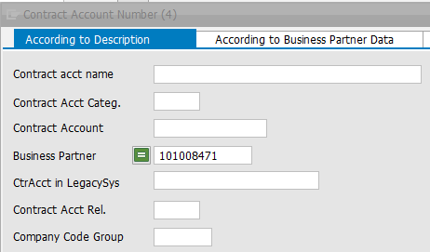
- Click the green tick:
- Double click the contract (or the preferred contract if multiple entries show)
- Repeat above for the Contract.
- Put 1000 in Company Code
- Leave Subapplication box as ‘9 Real Estate’
- Select List Type, Open and Clear all Master Data
- Click the green tick
- Menu/Environment/Generate Account Info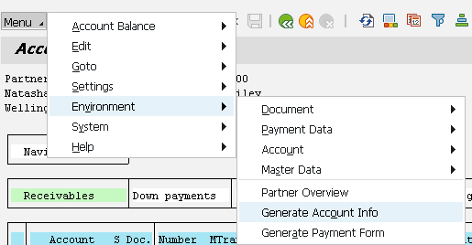
- The tab ‘Selection of Items’ should be open, see the screen shot:
- 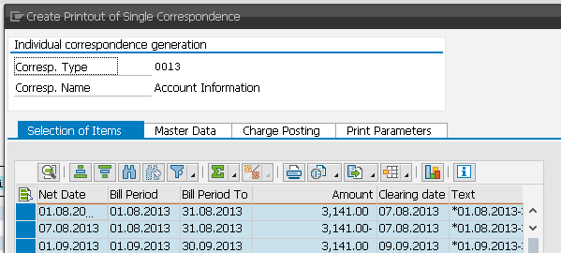
- It should show Net Date/Bill Period/Bill Period To/Amount/Clearing date/Text
- If not, choose layout, choose: /TENANCY1
- Click the symbol to the right of the printer symbol.
- Choose Excel in Place
- Highlight the figures (from A2)and copy (CTRL C)
- Move to cell A11 in the Excel Template and paste the data (CTRL V)
- Format the dates. Numbers in 41,000 range are dates, highlight all the dates and format as date.
- Sort (using the filter symbols in row 10) the figures on Amount Paid, Largest to Smallest
- Work down the Comments (currently in the Arrears total column) and delete all entries apart from Water Rates or other non-rent entry.
- Cut and paste the remaining comments into column h – the comment column.
- Scroll down to the negative amount figures.
- Copy the Clearing Date for the payments to the column immediately to the right – the date paid column
- Delete the dates above that apply to rent (in the amount paid column)
- Cut and paste the payments (only the negative numbers) into the column immediately to the right.
- Format the Due date, From and To Dates for all payments as white text. This is so they disappear but can still be sorted.
- Sort the table of figures on Column A - the Due Date (Oldest to Newest)
  - Make sure that the sort contains all of the data
- Remove fill colour and all borders
- Check formats of cells
- Work down the whole sheet looking for multiple entries for the same day.
- Eliminate all repeats by:
  - Finding the total for that day
  - Typing the total into the first entry
  - Deleting the other entry rows
- When finished, copy the Arrears Total Formula (in G10) down through the whole selection
- Check the totals are displaying correctly
- Save (change name) and print

