RE80/CJ12: Activate WBS Element Transaction Guide

This guide shows you how to use transactions RE80 and CJ12 (via RE80) to identify and activate the relevant Work Breakdown Structure (WBS) element for an Acquisition, Management or Disposal WBSE.

Note: The WBSE’s will display in the assignments tab of the property AO as displayed here:

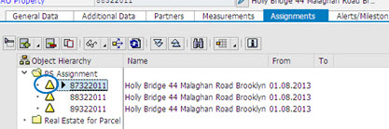

For example:
87322011 ACQ WBS
88322011 MM WBS
89322011 DISP WBS

This transaction is part of the following processes:

- PM 5.2 Create Property Record – Purchase Approved
- PM 5.3 Purchase Property
- PM 7.1 Lease Property
- PM 7.2 Licensing/Leasing Utilisation of Road Reserve

Use either the short description quick-step procedure below or the detailed procedure with screen shots from page 2 onwards. Access RE80 using either:
- transaction code RE80, or
- the menu path: Real Estate Management > Master Data > RE Navigator.

Quick-step procedure
Follow the steps below to complete this transaction.

Step | Action
On the Object Overview tab, select Architectural Object from the drop-down list and click the Find icon.
Result: The Restrict Value Range dialog box displays.
 | Select a suitable search (e.g. Architectural Object by Address).
 | Enter search criteria (e.g. part of the address) and press Enter.
 | Select the architectural object (property) from the displayed list by double-clicking on the item in the list that displays. (The Architect. Object Property <88******> Display: General Data screen displays.)
 | Click on the Assignments tab.
 | Click on the relevant WBS element (e.g. 87322011) to view the details in the WBS Element tab.
 | Click the display/change button to go into change mode
 | Double click the triangle next to the ACQ WBSE. This will move you directly into CJ12 to activate WBSE.
Click in the tickbox beside Acct asst elem.
Note: when ticked, this activates the WBS element and allows costs to be settled to it.
To link to a PPM project WBS element, do the following:

- Click the Settlement Rule button in the menu.
- Click in the Cat (Category) field and choose WBS element in the Maintain Settlement Rule: Overview screen.
- Enter the relevant project WBS element in the Settlement Receiver field.
- Click Back to return to the Change WBS Element: Basic Data screen.

Note: This step will only be possible when the PPM project financial structure is loaded.
Click Save.
Result: The message ‘WBS element <number> is being changed’ will display on the Change WBS Element: Initial Screen. The WBS element will now be activated

Detailed procedure

Follow the steps below to complete this transaction.

- On the Object Overview tab, select Architectural Object from the drop-down list and click the Find icon (circled in blue below).

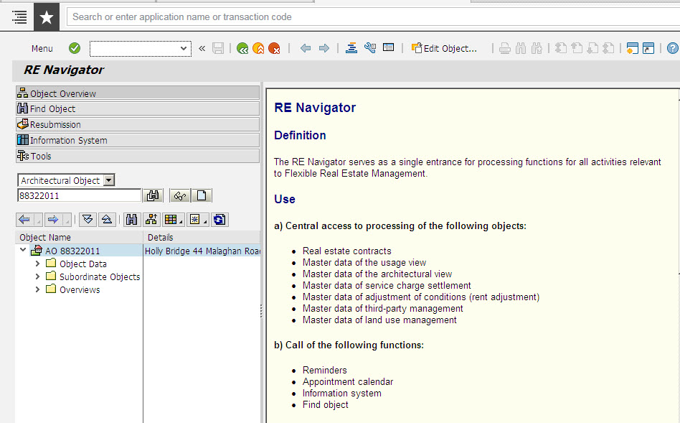

Result: The Restrict Value Range dialog box displays.

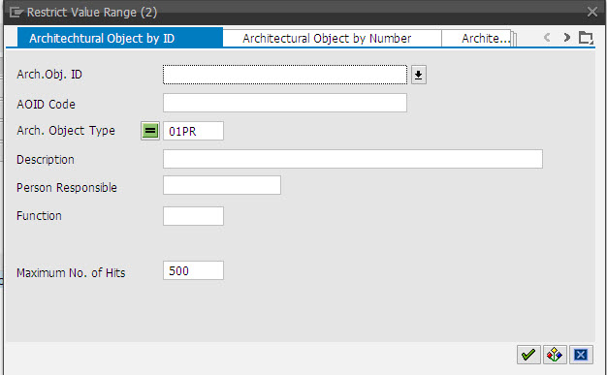

- Select a suitable search (e.g. Architectural Object by Address).

- Enter search criteria (e.g. part of the address) and press Enter.

- Select the architectural object (property) from the displayed list by double-clicking on the item in the list that displays.

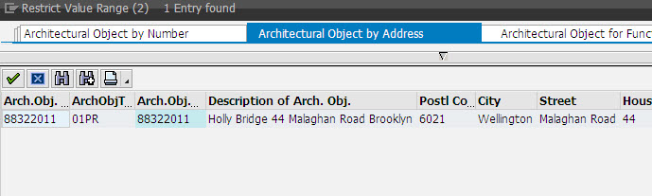

Result: The Architect. Object Property <88******> Display: General Data screen displays.

Note: If a search list does not display, review your selection criteria, make any changes and press Enter to search again.

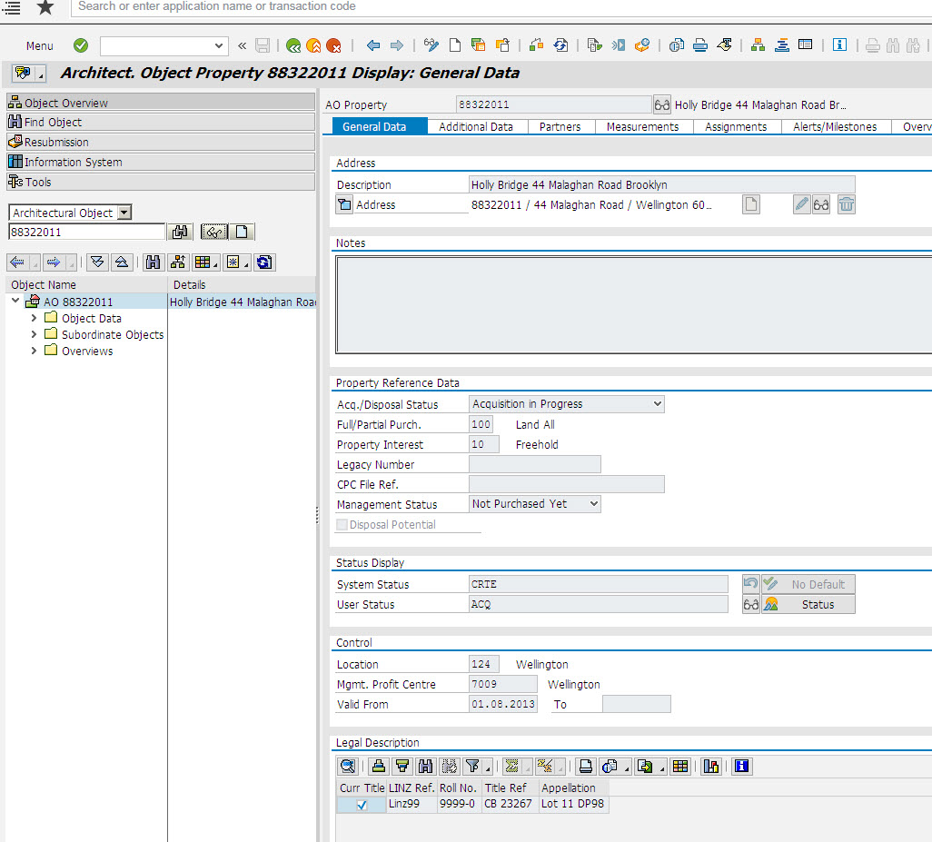

- Click on the Assignments tab.

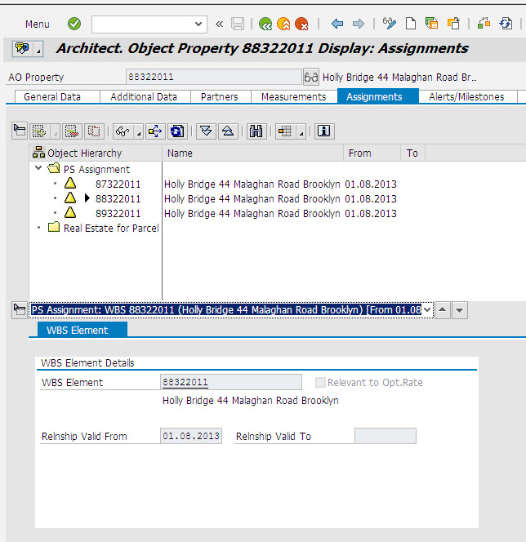

- Click on the relevant WBS element (e.g. 87322011 for the ACQ WBS) to view the details in the WBS Element tab (bottom half of the screen)

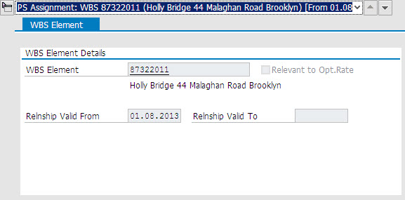

- Click the display/change button to go into change mode

- Double click the triangle next to the ACQ WBSE. This will move you directly into CJ12 to activate WBSE.

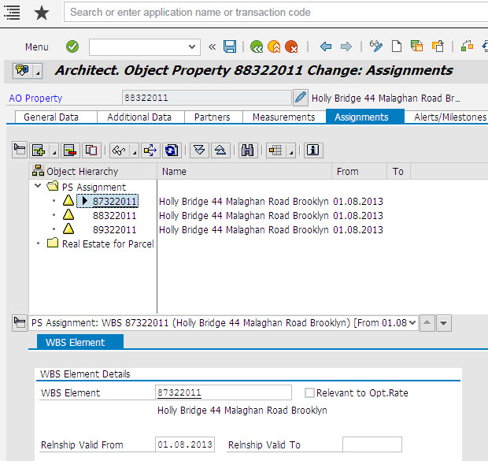

- Click in the tickbox beside Acct asst elem. (when ticked, this activates the WBS element and allows costs to be settled to it).

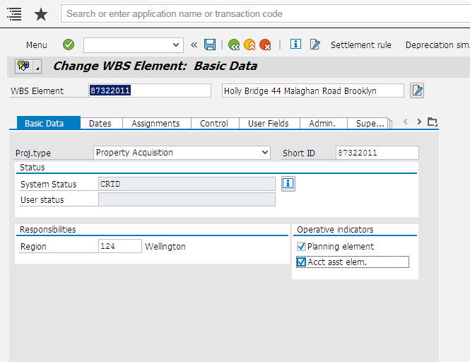

- To link to a PPM project WBS element, do the following:

- Click the Settlement Rule button in the menu.
- Click in the Cat (Category) field and choose WBS element in the Maintain Settlement Rule: Overview screen.
- Enter the relevant project WBS element in the Settlement Receiver field.
- Click Back to return to the Change WBS Element: Basic Data screen.

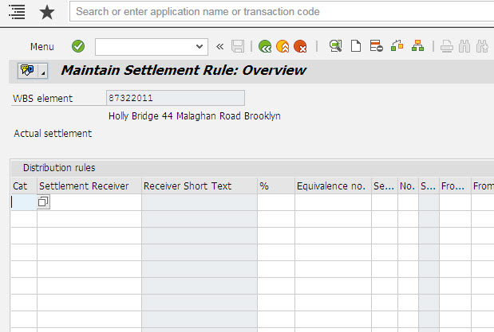
Note: This step will only be possible when the PPM project financial structure is loaded.

- Click Save.

Result: The message ‘WBS element <number> is being changed’ will display on the Change WBS Element: Initial Screen. The WBS element will now be activated.

