CONSULTATION FOR THE REQUIREMENTS FOR URBAN BUSES in new zealand (RUB) REVIEW – AN overview
This overview accompanies, and provides context for, the public consultation draft of proposed changes to the national Requirements for Urban Buses in New Zealand 2014 (RUB) guidelines. https://www.nzta.govt.nz/resources/requirements-for-urban-buses/

The proposed changes will improve national consistency, safety and accessibility for all urban bus users, and enable the transition to more environmentally-friendly buses in New Zealand’s national bus fleet.

If you wish to comment on this draft Requirements for Urban Buses in New Zealand 2014 (RUB) document, please see Making a Submission (p4) for details on how to do this. The deadline for submissions is 5pm on Friday 6th November 2020.

The Requirements for Urban Buses in New Zealand 2014 (RUB)
The purpose of the Requirements for Urban Buses in New Zealand 2014 (RUB) is to standardise urban bus requirements across regional councils and Auckland Transport (AT) to create efficiencies and improve the usability and accessibility of buses for all customers.
Since the RUB was first adopted in 2008 it has been reviewed twice (in 2011 and 2014) and updated in 2013 to accommodate double decker buses. National adoption of the RUB has led to improvements in bus fleets that have delivered:
- Newer buses (more new vehicles and a lower average fleet age);
- Significantly improved emissions from urban buses as higher Euro standards are met;
- More low-entry (and kneeling) buses;
- More wheelchair accessible buses; and
- Improved customer satisfaction with buses.

The Requirements for Urban Buses in New Zealand 2014 (RUB) Review
Waka Kotahi NZ Transport Agency (the Transport Agency) is currently reviewing the Requirements for Urban Buses in New Zealand 2014 (RUB), in line with its stated 3-year update objective to:
- create national consistency and efficiency of the bus fleet;
- ensure bus standards are up to date in a world of rapidly developing vehicle technology and;
- improve access to social and economic opportunities for the transport disadvantaged.
The regular 3-yearly update to the document was delayed due to the New Zealand General Election in 2016 and has been further delayed due to the COVID-19 pandemic. These improvements will only apply to new buses entering service and are not retrospective.

The following benefits are expected from this review:
Benefit | Measure
Alignment with the objectives of the Public Transport Operating Model and the Agency’s focus area around improved customer experiences | Stakeholder satisfaction, efficiency and national consistency.
Ability for regional councils to move buses around the country | National consistency in bus design creates enhanced efficiency and cost savings for councils and a better customer experience of the bus.
Affordable, accessible, safe, attractive and easy to use vehicles | Customer satisfaction surveys  Vehicle quality/comfort:  - Increasing proportion of customers who rate PT vehicles as ‘very good’ or higher
Improved accessibility | - Increasing proportion of urban bus fleet is low-entry floor.  - Increasing proportion of urban bus fleet is wheelchair accessible.
New technology | Faster uptake of electric buses, in line with Government objectives for EVs
Improved emissions | Increasing proportion of urban bus fleet Euro VI-C (or better) and electric-battery buses.

The Transport Agency has held detailed consultation meetings with regional councils, bus industry builders and operators, and representatives from the Disability Sector to gather feedback and input on the document content. These meetings have informed the Transport Agency’s proposed changes to the RUB. We now wish to consult with the wider New Zealand community on the proposed changes.

The consultation process for the Requirements for Urban Buses in New Zealand 2014 (RUB) Review
This publication provides the context for consulting on the proposed changes to the Requirements for Urban Buses in New Zealand 2014 (RUB).
Everyone who travels on an urban bus will be affected by these proposed changes. We want to be sure we consider your views, and the impact that the proposed changes could have on you.
We’re consulting on our proposed changes to ensure that:
- the RUB review process takes this into account, and
- our national urban bus guidelines are sound and robust.
We’ll analyse the feedback we receive from you and take it into account when we finalise our proposed changes. Then, the RUB document will be approved and ratified by the Transport Agency. We expect most of the proposed changes to be adopted by Q1 2021.

Making a Submission
We want to hear what you think.
We have provided a series of questions throughout this document that seek your views. This will help us understand the impact that the proposed changes could have. These are outlined throughout this document, and in the online survey.
The questions are intended as a guide, and you do not have to answer them all. You may choose to answer only those that interest or impact you. Or, you can simply tell us what you think about the changes in your own words.

You can make a submission in the following ways:
- Fill in the online survey: xxxxx link here
or
- Fill in the submission form, which contains the range of questions.
or
- Write us a letter, email, or make a video telling us what you think.

Please include the following information in your submission:
- the title – Requirements for Urban Buses in New Zealand (2014) Review 2020
- your name,
- your job title and organisation’s name, if applicable
- your organisation’s name, if applicable
- your address or email address.

- Send your submission to us by email to publictransport@nzta.govt.nz

- You can post us your submission to:
Requirements for Urban Buses in New Zealand (2014) Review 2020
Transport System Policy Team
Free Post 65090
Waka Kotahi NZ Transport Agency
National Office
Private Bag 6995
Wellington 6141

Please note the deadline for submissions
The deadline for submissions is 5pm on Friday 6th November 2020.

Your submission is public information
We will use your submission to help us make the changes to the Requirements for Urban Buses in New Zealand 2014 (RUB).
Please note that the Transport Agency will publish a summary of submissions. If you do not want your name or any identifying information to be included in anything we publish (including because you believe your comments are commercially sensitive) please indicate this clearly in your submission.
Please note that your submission is also subject to the Official Information Act 1982 (OIA). This means that other people will be able to obtain copies of submissions by making a request under the OIA. If you think there are grounds for your information to be withheld under the OIA, please note this in your submission. We will take your reasons into account and may consult with you when responding to requests under the OIA.

Information you need to make a submission
The Government is committed to ensuring that national transport guidelines are sound and robust, and that our review process considers your views.
Please read this document carefully and consider what effects these changes would have on you or your organisation (if relevant).

Proposed timetable for implementation
Subject to the approval of the Transport Agency, we propose that the changes take effect in the 2021 financial year.

Feedback from stakeholders and industry that has influenced the Requirements for Urban Buses in New Zealand 2014 (RUB) Review
National consistency
Despite some obvious gains resulting from the introduction of the Requirements for Urban Buses in New Zealand 2014 (RUB), there have been matters raised by stakeholders and the industry which suggest that a review in accordance with the review cycle is timely. Some feedback is that the RUB is not being adhered to, which is undermining its purpose of achieving national consistency for the usability and accessibility of buses. Some regions were granted variations from the RUB to allow things such as increased seat spacing, and larger rear doors (AT) and fire suppression equipment (GW).
Disability Sector’s concerns
The national Disability Action Plan (DAP) 2019-2023 for New Zealand has been developed by the Ministry of Social Development (MSD) in conjunction with government agencies, and the Transport Agency’s internal Disability Action Plan was agreed upon at the end of 2019. While specific transport issues were not identified by the Independent Monitoring Mechanism (IMM) as one of the six key issues to be focused on in the new DAP, the feedback from the Disabled People’s Organisations (DPO) Coalition and disabled communities highlighted the importance of improving disabled people’s access to, and experience of, the transport system and providing them with more choices and control of their journey – access to the transport network enables safe and equitable participation in social, educational and economic opportunities.
In relation to buses in New Zealand and the RUB, disability groups have expressed concern over the lack of consistency between regions, including wheelchair locations, seat spaces, hand holds and grab handles, and ramp gradients. The groups have also raised concerns over the lack of audio and visual signage, and placement of ticketing machines on buses.
The Transport Agency’s 2018 position statement on inclusive access is that ‘everyone should have fair and equitable access to the transport system’, and we are working with the disability sector to ‘improve access to social and economic opportunities for the transport disadvantaged’. The three main councils, Auckland, Greater Wellington, and Environment Canterbury have responded to these issues by meeting with disability groups, and trialling audio and visual information on buses. In addition, creation of a Disability Advisory Group for transport-related issues is underway to provide lived experience and advice for the Transport Agency when developing policy that impacts on people with disabilities.
Environmental considerations
The Government is interested in reducing emissions, encouraging mode shift away from cars, creating more liveable cities and increasing access to social and economic opportunities by improving and providing more public transport.
Currently, new heavy vehicles entering the national bus fleet are required to meet Euro V emission standards, however, for urban buses we have taken the decision to require a minimum of Euro VI-C, as this is a much better environmental standard.
Recent technological advances in battery and charging technologies have made battery-electric buses a viable option for achieving these outcomes. These advances, combined with New Zealand’s commitment to reducing greenhouse emissions and government incentives to promote the uptake of electric vehicles, have resulted in a number of electric buses entering operations. Several of these electric buses are part of trials that have received funding from the Energy Efficiency and Conservation Authority’s (ECCA) contestable fund to promote the uptake of electric vehicles. In addition to these trials, electric buses are beginning to enter into the primary public transport fleet.
The RUB will be updated to include a definition of a large electric-battery bus and a large electric-battery double decker, and specifications for electric buses, including, information on dimensions, charging, and range without refuelling; and direction for charging buses have been discussed at upcoming industry consultation. An update to the RUB could speed up electric bus uptake, and the Ministry of Transport (MoT) has expressed interest in using the RUB to achieve reduced emissions.
Passenger and driver safety
Another key Government and Transport Agency priority is passenger and driver safety on buses. There have been concerns over passenger and driver safety while present on an electric-battery bus when it is charging. There have also been some assaults on drivers while they are taking their breaks – the emergency doors have been opened, and they have been attacked. In addition, the recent spate of bus crashes, and a death of an elderly passenger after a fall on a large electric-battery double decker (LEBDD) has led to a Ministry of Transport request into bus safety in general. These issues have been discussed during consultation.

Outline of the proposed changes to the Requirements for Urban Buses in New Zealand 2014 (RUB)

This section outlines the changes we’re proposing to make to the Requirements for Urban Buses in New Zealand 2014 (RUB) guidelines.
These proposed changes seek to:
- create national consistency and efficiency of the bus fleet;
- ensure bus standards are up to date in a world of rapidly developing vehicle technology and;
- improve access to social and economic opportunities for the transport disadvantaged

Proposal 1: Require bus wheelchair ramps to have a maximum gradient of 12%

Current requirement
The current 2014 RUB does not specify a maximum gradient for the wheelchair ramp.
Current RUB 2014 reference:
Section 6.5 Ramp
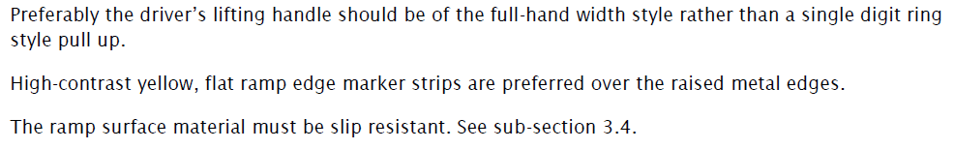

Issues with the current lack of requirement
Currently, there are many areas of New Zealand with insufficient or non-existent footpaths and kerbs, meaning that the wheelchair ramp cannot be deployed correctly for people to embark/disembark. This has repercussions for people with a disability in these areas, as they are unable to use local public transport and therefore cannot access economic, social, and educational opportunities.
We are concerned that without a maximum ramp angle or gradient being specified, this might continue the problems of national inconsistency and ramps that are too steep to be used.
Proposed change
We are looking for feedback for a proposed maximum ramp gradient of 12% for urban buses. This will enable access to the bus in secondary urban and rural areas with less developed infrastructure.
Proposed RUB 2020 reference:
Section 3.1 Ramp
A manually-operated flip-over style ≥800 mm width ramp must be provided at the front door that can be deployed and recovered by the driver on request, where the kneeling facility proves to be insufficient.
The maximum ramp gradient must be 12%.
Proposal 1: Require bus wheelchair ramps to have a maximum gradient of 12%

- Should bus wheelchair ramps should have a maximum gradient of 12%? What are your thoughts?

Proposal 2: Specify a height range of 900-1000mm for the installation of ticketing machines

Current requirement
There is no specification for the height range of the ticketing machine.
Current RUB 2014 reference:
Section 3.1 Introduction to the Priority seating area
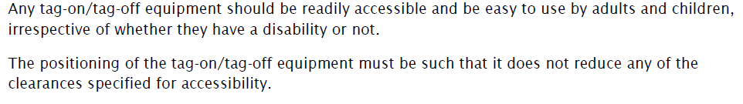

Issues with the current lack of requirement
This may mean the ticketing machine is mounted too low/high for a person in a wheelchair or for someone with a mobility restriction, e.g. injury or arthritis, to comfortably use. It may also interfere with the entry and exit of a person in a wheelchair if placed too low.
Proposed change
We are looking for feedback for a proposed height for ticketing machines of 900-1000mm for urban buses.
Proposed RUB 2020 reference:
Section 3.2 Ticketing/fare-collection area
Ticketing equipment and till stand should be ergonomically located for driver ease of use. Ticketing equipment and till stand must not impede the driver’s vision or access by wheelchairs, the height of the ticketing machine must be between 900-1000mm.
Proposal 2: Specify a height range of 900-1000mm for the installation of ticketing machines

- Do you agree with this height range? What are your thoughts?

Proposal 3: Create a second wheelchair space in the priority seating area on single-deck urban buses

Current requirement
There is currently one wheelchair/pram space provided on the nearside of single-deck urban buses (small and large buses).
Current RUB 2014 reference:
Section 6.3 Wheelchairs
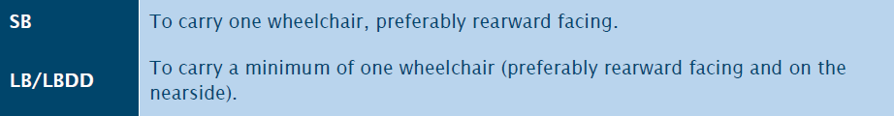

Issues with the current requirement
We have had feedback from the disability sector that people in a wheelchair who are travelling with a companion, who is also in a wheelchair, have had to catch separate buses due to a lack of a second wheelchair space.
Image one: Diagram showing priority seating area in RUB 2014
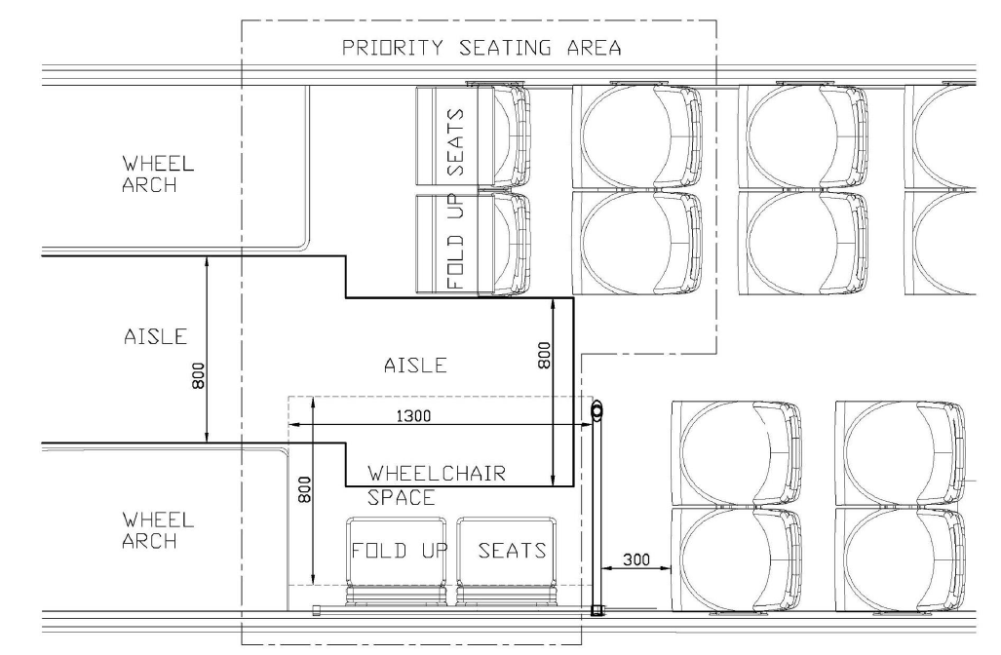
Proposed change
We propose that for single-deck urban buses, an additional multi-use/wheelchair space that will accommodate one wheelchair and user, or pram user, on the far side of the vehicle.

Image two: Indicative diagram showing proposed priority seating area in RUB 2020
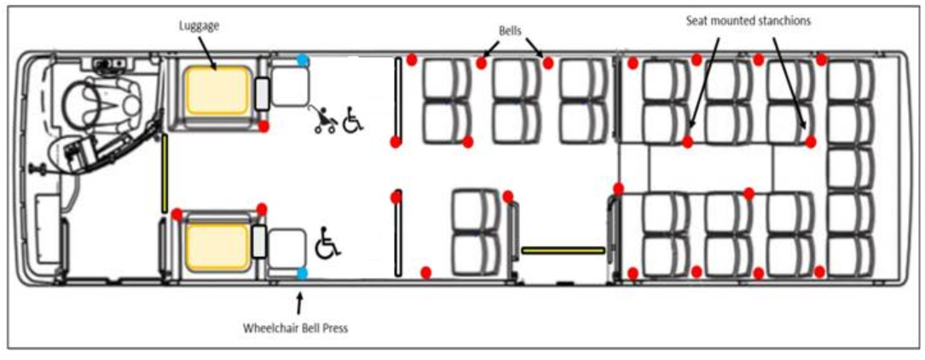

Proposed RUB 2020 reference:
Section 4.3 Priority seating area
For single-deck buses, an additional multi-use/wheelchair space that will accommodate one wheelchair and user, or pram user, on the far side of the vehicle.
Proposal 3: Create a second wheelchair space in the priority seating area on single-deck urban buses

- Should there be a second wheelchair space on single-deck urban buses? What are your thoughts?

Proposal 4: Require one sideways-facing folding seat on both the near and far sides of the bus, in the priority seating area

Current requirement
There are currently four seating positions in the priority seating area – two sideways-facing, folding seats on the nearside and two forward-facing, folding seats on the far side. There are also an additional two seats behind the folding seats on the far side. (See image one above).
Current RUB 2014 reference:
Section 3.1 Introduction to the priority seating area
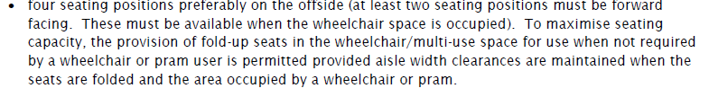

Issues with the current requirement
We have had feedback from regional councils that some passengers seated in the two forward-facing, fold up seats on the far side have sustained head injuries on the wheel arch, in the event of harsh braking or an accident.
Additionally, feedback has also indicated that passengers seated in the two side-ways facing seats on the nearside are too closely spaced, resulting in head-strike incidences. There is also no handrail to hold onto in an emergency.
Proposed change
We propose that single-deck urban buses have one, sideways-facing, folding seat on both the near and far sides of the bus, in the priority seating area, immediately behind each wheel arch, with a horizontal handrail for safety (See image two above).
Proposed RUB 2020 reference:
Section 4.3 Priority seating area
• One side-ways facing, folding seat will be located immediately behind each wheel arch - to facilitate wheelchair access and stowage. Any fold-up seat must be capable of being held in the stowed position.
• There must be a horizontal handhold for occupants of sideways seats
Proposal 4: Require one sideways-facing, folding seat on both the near and far sides of the bus, immediately behind the wheel arch, in the priority seating area.

- Do you agree? What are your thoughts?

Proposal 5: Allow different types of mobility devices onto urban buses

Current requirement
Under the current RUB requirement, the only mobility devices allowed onto a bus are wheelchairs – both manual and electric.

Issues with the current requirement
Feedback from the Disability Sector has indicated that there are many different types of mobility devices available on the market, and the Accident and Compensation is providing their clients with many newer types of devices to help them after an injury or accident.
The RUB is currently very limited in which devices are allowed onboard, meaning some people using newer types of mobility devices do not use buses, limiting their mobility and access to the transport system. The Disability Sector has requested that the Transport Agency consider different types of mobility devices, in order to future proof the RUB.

However, some kinds of mobility devices, such as segways, can be dangerous because they cannot be secured properly onboard, may fall over, and can become projectiles in the event of harsh braking or an accident.

Current RUB 2014 reference:
Section 6.3 Wheelchairs
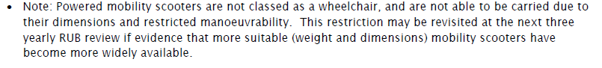
Proposed change
Allow different kinds of mobility devices onboard urban buses, however, they must adhere to specific maximum size, weight, and height measurements to ensure the safety of passengers (see measurements in blue box below).

- Include a sign at the entrance door specifying the maximum size/weight/height of device allowed.
- Device must be able to be secured or stored safely.

Proposed RUB 2020 reference:
Section 4.3 Priority seating area
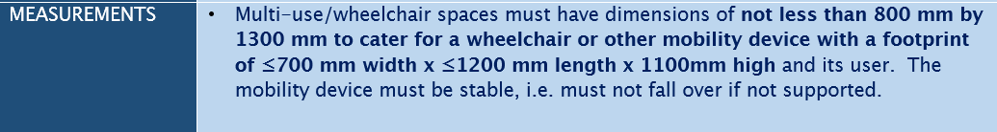
Proposal 5: Should different types of mobility devices be allowed on urban buses, if they adhere to specified maximum measurements?

- Do you agree? What are your thoughts?

Proposal 6: Install a wheelchair-specific button to indicate to the driver when to deploy the ramp

Current requirement
There is no specific bus stop button for wheelchairs. The current priority area buttons do signal to the driver that a passenger may need time and assistance to exit the bus.
Current RUB 2014 reference:
Section 5.2 Bus stopping signals
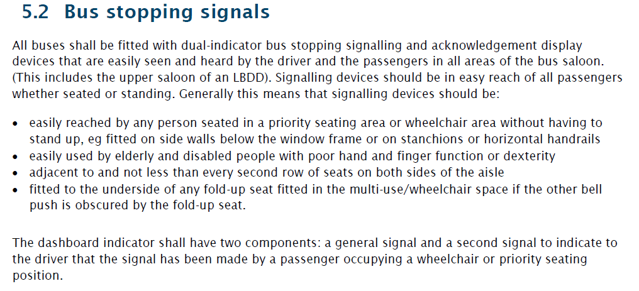

Issues with the current lack of requirement
Currently, there is a two-level hierarchy for bus stop buttons – one button for the general bus saloon, and another for the whole priority area.
When there are many passengers (seated or standing) in the priority area and the priority bus stop button is pushed, it can be difficult for a driver to know if a passenger wanting to disembark is in a wheelchair.
Proposed change
We are seeking feedback on the proposal to install one blue button on each side of the bus. These buttons must be located in close proximity to the designated wheelchair spaces and must not be easily accessible to other passengers (see the blue dots in the diagram below).
Image five: Indicative diagram showing proposed wheelchair bus stop buttons in RUB 2020
Proposal 6: Provide a bus stop button for wheelchairs in the priority area

- Do you agree? What are your thoughts?

Additional feedback:
Do you have any other additional feedback or comments on any other content in the draft RUB?

