Stuck in traffic? -Try carpooling
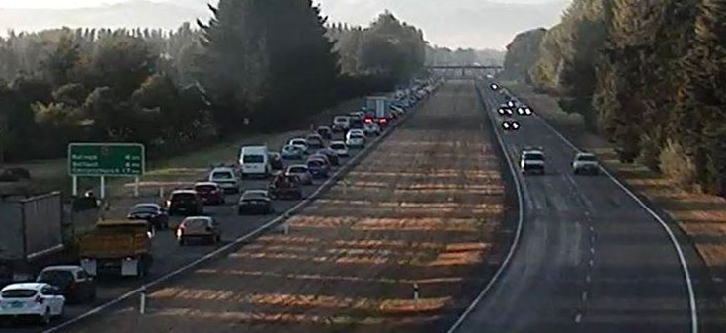.

“Just remember, you are not stuck in traffic, you are the traffic,” said Carl Davidson, to a roomful of people at the Rangiora Town Hall in May. People from Hurunui and Waimakariri Districts had come to hear more about the results of a commuter travel survey, conducted by Carl’s company Research First, on behalf of the NZ Transport Agency and council partners.
His words rang true for most of us who had travelled north that night. There had been a crash at the start of the motorway so some of us took an hour-and-a-half to travel 26 or so kilometres between the city and Rangiora.
The over-riding advice from the survey, based on the insights of 388 North Canterbury commuters, is for people to consider carpooling to reduce congestion and make the journeys more efficient for everyone. Around 80 percent indicated they are open to the idea of carpooling, or already do carpool.
Around 85% of all vehicles on the northern route contain just one person with about 50,000 traffic movements each day across the Waimakariri River, up 10,000 since the earthquakes. The current infrastructure work on Marshland Road, usually the quickest route for Kaiapoi residents, is also adding to the peak time volumes on the Northern Motorway.
Carpooling snap
One recent convert to carpooling is John Whittaker, of Mandeville, who thought he was unlikely to find anyone who travelled near to his work in Birmingham Drive, when he tried the www.letscarpool.govt.nz website.
But as a result, he is now happily carpooling with Ken Fortune, of Swannanoa. Bizarrely enough, they both work for the same company and drive the same make of car. Both have sons who get dropped off to school and picked up after sports some nights.
“I enjoy carpooling more than driving by myself,” John says. “I get to relax and be driven every other day, and I can use that time to chat or to catch up on some video courses. My son reads and Ken's son often plays games on his laptop. It's a busy car.”

Ken notes that the average carpooler will save over $2000 a year in fuel bills and that also means a tonne less carbon dioxide in the atmosphere.
No silver bullet
Long-term, there will always be peak-time congestion on the Northern Motorway, even when the new Western Corridor (currently underway by the Transport Agency as part of the Government’s Roads of National Significance programme) and Northern Arterial (starting later this year) are completed, because of the continual growth in traffic from the north. However, once these new routes are completed, there will be much greater predictability around times at peak hours. This gives people better ability to plan with certainty.
The Transport Agency’s short-term congestion solutions include the new variable speed signs, which reduce the length and duration of the backlogged traffic tail north of Belfast in the morning. These are working but they are not the full solution.

What can we do to make carpooling and buses more attractive?
The North Canterbury people surveyed said they wanted incentives, like carpooling lanes, to make it a more attractive choice. The Transport Agency has looked at this but there are a number of technical issues if these are to be operated safely. Additional length of dedicated bus lanes have been added along Main North Road and more are being investigated at Chaneys.
With a new Metro service planned between Waimakariri and the Airport and Hornby, taking the bus will become increasingly attractive. The new service starts on 25 July.
People at the meeting also had plenty of other ideas. ECan representatives explained why the train or rail option to Rangiora was not practical or affordable in the short term. Transport Agency staff discussed why another bridge to the west across the Waimakariri with a link to Tram Road would be an enormously expensive project when you took land purchases and the kilometre-wide braided river into account.

Useful links
Smart Travel NZ:
https://www.smarttravel.org.nz/
The results of the survey are online: http://www.nzta.govt.nz/Northern-Corridor-Research-Report.pdf
Motorway Manners - four short videos with tips for commuters: http://ow.ly/4ndJOA

By Jim Harland, Regional Director, Southern, NZ Transport Agency

