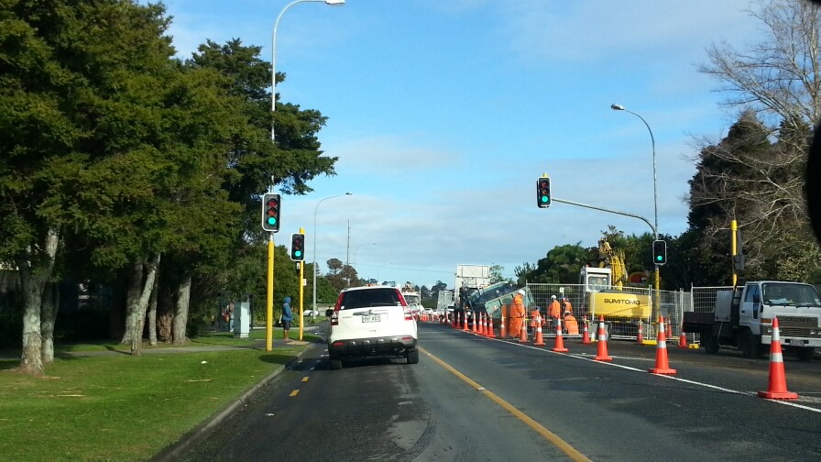
Document name
Organised on demand
(requires a minimum of 7 participants)
Advanced Traffic Management Planning (ATMP) workshop

Advanced Traffic Management Planning (ATMP) workshop

About the ATMP workshop
The CoPTTM Governance Group (CGG) prioritised the development of an advanced planning workshop for TMP designers, reviewers and approvers.
NZTA has developed the workshop and introduced a new STMS qualification of Advanced Traffic Management Planner (STMS-AP). The issuing of this qualification is dependent on the attendees completing the workshop and a back at work assessment.
The 2-day workshop focusses on planning the TTM for a worksite, with an emphasis on complex situations. Note: Complex means a major change to road user conditions, the sort that comes with large projects or where large traffic flows need to be managed.
The workshop has been designed with the following roles in mind:
- STMS involved in developing TTM documents for complex sites
- Project planners
- TMCs and other TMP approvers
- Auditors.

What it covers
The workshop covers the following steps:
- Identifying matters to be addressed
- Planning the closure(s)
- Planning for other considerations
- Planning for the road users
- Resolving conflicts
- Developing the TMP
- Submitting the TMP for approval
- Reviewing approval documentation (eg TMP, consent to work, other authorisations)
- Pre-implementation of the TMP
- Implementing the TMP
- Completing a TTM review.
During the workshop drawing standards for a TMD will be outlined, including an introduction to different drawing options (eg Invarion, CAD, MSOffice). Follow-up training sessions can be arranged with practitioners for each of the site drawing options. A list of these practitioners will be made available during the workshop.

Eligibility for attendance
To be eligible, attendee’s must:
- Hold a current STMS warrant
- Be competent with word processing to an intermediate level (add/amend tables, format text etc.)
- Be able to navigate CoPTTM to find required information
- Be able to clearly express an idea in writing (completion of a detailed TMP form).

ATMP Registration Form

ATMP Registration Form
Name:
Location:
Organisation:
Address:
Email:
Telephone:
Any special requirements (eg dietary needs, limited mobility)

- Please advise all interested parties to contact Kim Laurenson (copttm.quals@nzta.govt.nz) to reserve a place at the workshop and to receive joining instructions. This workshop will be restricted to 15 attendees.
- The charge for the workshop is $1,250 plus GST per person.
- The charge for the follow-up competency assessment will be $1000 plus GST. This covers the marking of your plan, feedback and checking of minor alterations. Additional charges may apply for major revisions or additional assessments.
- Lunches are provided but attendees are responsible for their own travel and accommodation costs plus evening meals.
- If there is a need to discuss the workshop, please contact either:
  - stuart.fraser@nzta.govt.nz, or
  - neil@ngtc.co.nz, or
  - tony@stellaassociates.co.nz

