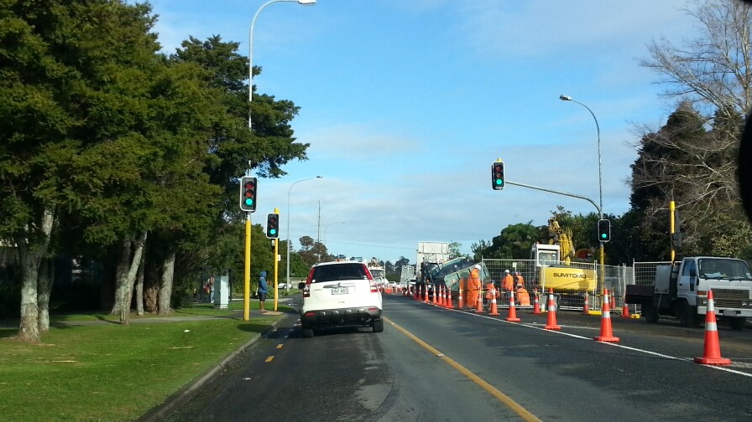
Document name
Date: 25 and 26 May 2017 (Please note change of date)
Location: Invercargill – Ascot Park Hotel
Tay Street and Racecourse Road
Traffic Management Coordinator (TMC) Workshop

TMC workshop
About the TMC workshop | Who should attend
This 2-day workshop focusses on local and national issues, is highly interactive and aims to establish a coordinated approach among the TMCs and other key people within the area. | The workshop has been designed with the following roles in mind:  - TMCs and other TMP approvers  - Corridor Managers  - Auditors.
What it covers
The workshop covers the following:  - Section A TMC role  - Section A Processes and network management  - Section A TMPs  - Section A Coordination | - Section B Equipment review (What we allow on the network)  - Section C Static closures  - Mobile operations  - Auditing  - Network management and communication  - Summary and forum discussion.

TMC Registration Form
- Please complete the form below and email it to Kim Laurenson copttm.quals@nzta.govt.nz to reserve a place at the workshop and to receive joining instructions. This workshop will be restricted to 14 attendees.
TMC Registration Form
25 and 26 May, Invercargill – Ascot Park
Name:
Organisation:
Address:
Email:
Telephone:

- Please advise people interested in attending the workshop to contact Kim Laurenson (copttm.quals@nzta.govt.nz) to reserve a place at the workshop.
- There will be no charge for attendance, but attendees will need to meet their own travel and any accommodation costs.
- If there is a need to discuss the workshop, please contact either:
  - stuart.fraser@nzta.govt.nz, or
  - neil@ngtc.co.nz, or
  - tony@stellaassociates.co.nz

