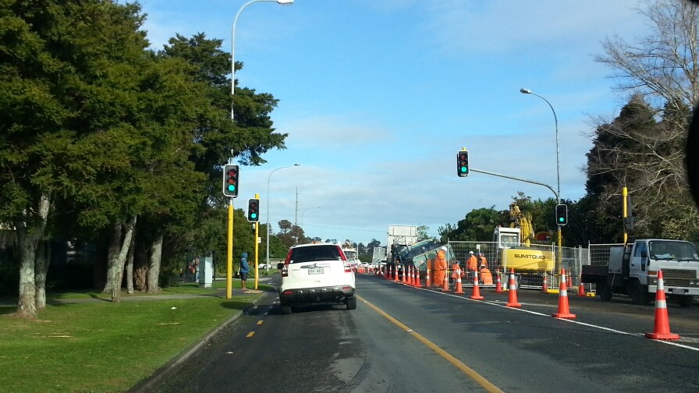
Advanced Traffic Management Planning (ATMP) workshop

Location: | Wellington
Date: | 17 and 18 July 2018
Venue: | Aotea Lodge – Kauri room  65 Whitford Brown Ave, Papakowhai, Porirua,

Advanced Traffic Management Planning (ATMP) workshop

About the ATMP workshop
The CoPTTM Governance Group (CGG) prioritised the development of an advanced planning workshop for TMP designers, reviewers and approvers.
NZTA has developed the workshop and introduced a new STMS qualification of Advanced Traffic Management Planner (STMS-AP). The issuing of this qualification is dependent on the attendees completing the workshop and a back at work assessment.
The 2-day workshop focusses on planning the TTM for a worksite, with an emphasis on complex situations. Note: Complex means a major change to road user conditions, the sort that comes with large projects or where large traffic flows need to be managed.
The workshop has been designed with the following roles in mind:
- STMS involved in developing TTM documents for complex sites
- Project planners
- TMCs and other TMP approvers
- Auditors.

What it covers
The workshop covers the following steps:
- Identifying matters to be addressed
- Planning the closure(s)
- Planning for other considerations
- Planning for the road users
- Resolving conflicts
- Developing the Full TMP
- Submitting the Full TMP for approval
- Reviewing approval documentation (eg TMP, consent to work, other authorisations)
- Pre-implementation of the Full TMP
- Implementing the Full TMP
- Completing a TTM review.
During the workshop drawing standards for a TMD will be outlined, including an introduction to different drawing options (eg Invarion, CAD, and MSOffice). Follow-up training sessions can be arranged with practitioners for each of the site drawing options. A list of these practitioners will be made available during the workshop.

Eligibility for attendance
To be eligible, attendee’s must:
- Hold a current STMS warrant
- Be competent with word processing to an intermediate level (add/amend tables, format text etc.)
- Be able to navigate CoPTTM to find required information
- Be able to clearly express an idea in writing (completion of a detailed Full TMP form).

ATMP Registration Form

ATMP Registration Form
Name: |  | PO Number:
Location:
Organisation:
Address:
Email:
Telephone:
Any special requirements (eg dietary needs, limited mobility)

- Please advise all interested parties to contact Kim Laurenson (copttm.quals@nzta.govt.nz) to reserve a place at the workshop and to receive joining instructions. This workshop will be restricted to 15 attendees.
- The charge for the workshop is $1,250 plus GST per person.
- The charge for issuing the warrant card will be $40 + GST.
- Assessment will be by submission of 3 approved Full form TMPs that have been successfully implemented on a road network.
- Details of the requirements of content of these TMPs will be given at the workshop.
- There will be a charge of $300 + GST for the review of the 3 submitted TMPs. This fee is to cover the time for the reviewer to review and give feedback.
- The warrant will be issued once the 3 TMPs submitted have been agreed as meeting the acceptable standard as demonstrated on the workshop.
- Local conditions which allow an approval below the standard expected MUST be outlined, discussed and accepted by the review team prior to the TMP being submitted FOR APPROVAL. If this does not happen the TMP will not be considered for sign off for the warrant.
- Lunches are provided but attendees are responsible for their own travel and accommodation costs plus evening meals.
- If there is a need to discuss the workshop, please contact either:
  - neil@ngtc.co.nz, or
  - tony@stellaassociates.co.nz or
  - stuart.fraser@nzta.govt.nz,

