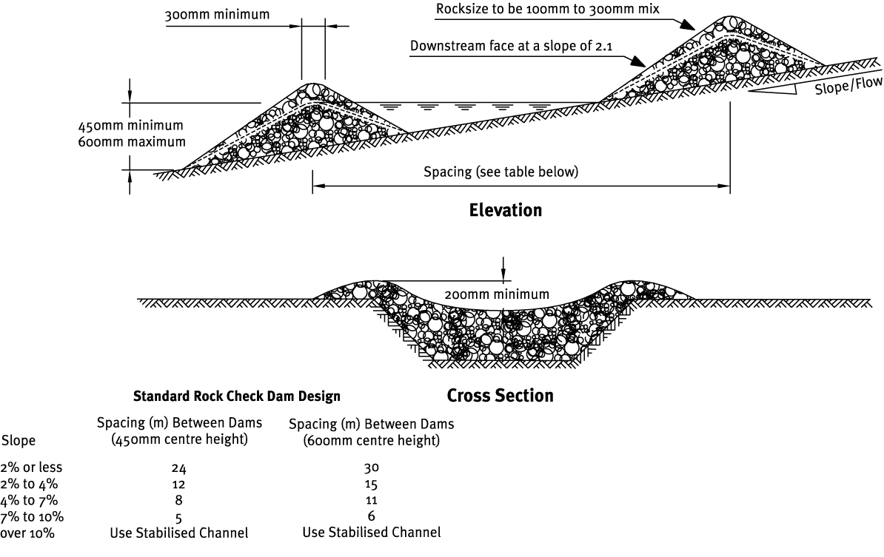
Contractor:  Inspector: | Date:  Time: |  |  | Consent #: |  |  | Site:
Site Inspection of Erosion and Sediment Control Practices
Erosion and Sediment Control Practice |  | Yes | No |  | N/A | Corrective Action
General Information
Do you know what receiving system the project drains into
Are you aware of local rainfall patterns during various times of the year
Soil types and erosion potential for site
Is a copy of the erosion and sediment control plan on site
Is temporary fencing placed in areas where no construction is to take place
Construction
Are there spillways in the centre of the check dams to avoid flow outflanking the edges of the dams
Are they spaced so the toe of upstream dams is at approximately the same elevation as the centre crest of the downstream ones?
Maintenance
Have dams been repaired when they have suffered machinery damage?
Have dams been inspected after rainfall or storms and repairs done as necessary?
Is there evidence of water outflanking the dams? Is there any scour around the edges or scour between the check dams?
Sediment accumulation behind the dams should be checked after each significant rain event and removed when depth exceeds 40% of original height.
Decommissioning
Remove check dams when no longer needed.
Do not remove check dams that are protecting grass-lined channels until a complete and sustainable ground cover has been achieved.
Areas disturbed by the removal process must be seeded, fertilised and protected from erosion.

