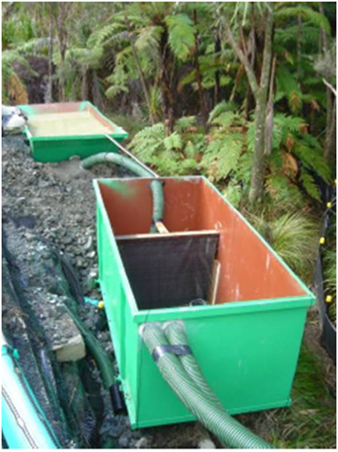

Contractor:  Inspector: | Date:  Time: |  |  | Consent #: |  |  | Site:
Site Inspection of Erosion and Sediment Control Practices
Erosion and Sediment Control Practice |  | Yes | No |  | N/A | Corrective Action
General Information
Do you know what receiving system the project drains into
Are you aware of local rainfall patterns during various times of the year
Soil types and erosion potential for site
Is a copy of the erosion and sediment control plan on site
Is temporary fencing placed in areas where no construction is to take place
Construction
Always dewater the cleaner water at the top first then pump the residual sediment laden water to a tank/truck
Small volumes of sediment laden water can be pumped to a silt fence or decanting earth bund but do not overwhelm these practices
Larger volumes can be pumped to a sediment forebay of a sediment retention pond
Maintenance
Ensure that the area being pumped to provides effective sediment removal
Check for any leakage or flow bypass of practices
Decommissioning
Remove when the need no longer exists

