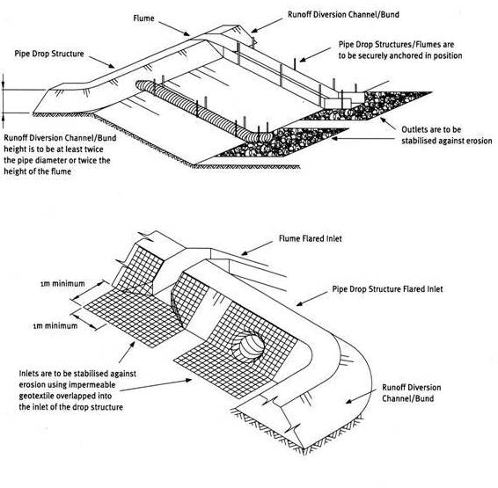

Contractor:  Inspector: | Date:  Time: |  |  | Consent #: |  |  | Site:
Site Inspection of Erosion and Sediment Control Practices
Erosion and Sediment Control Practice |  | Yes | No |  | N/A | Corrective Action
General Information
Do you know what receiving system the project drains into
Are you aware of local rainfall patterns during various times of the year
Soil types and erosion potential for site
Is a copy of the erosion and sediment control plan on site
Is temporary fencing placed in areas where no construction is to take place
Construction
Use when slopes > 3:1
Do not use on slopes < 5:1
Must be of an impervious material
Diversion channel or bund must be 2 x height of flume or pipe
Must have a stabilised entry apron to prevent scour or piping
Must extend beyond toe of slope with erosion protection at outfall
Maintenance
Inspect weekly and after each rain
Keep the inlet open at all times
Check for evidence of water bypass, undermining, ponding or overtopping.
Check for scour at the base of the pipe and repair, protect or reduce flows
Decommissioning
When areas draining to the pipe are controlled, all disturbed areas stabilised and permanent stormwater drainage has been installed.

