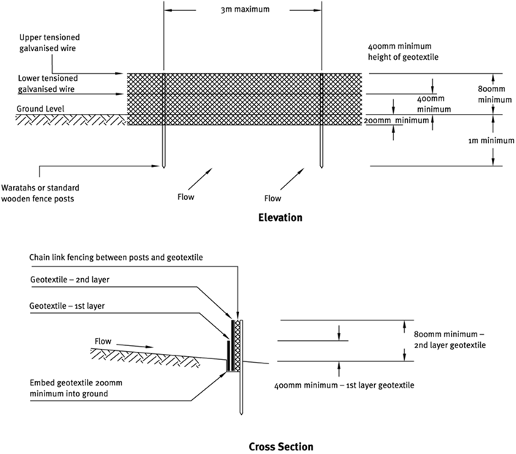

Contractor:  Inspector: | Date:  Time: |  |  | Consent #: |  |  | Site:
Site Inspection of Erosion and Sediment Control Practices
Erosion and Sediment Control Practice |  | Yes | No |  | N/A | Corrective Action
General Information
Do you know what receiving system the project drains into
Are you aware of local rainfall patterns during various times of the year
Soil types and erosion potential for site
Is a copy of the erosion and sediment control plan on site
Is temporary fencing placed in areas where no construction is to take place
Construction
Use super silt fence material appropriate to the site conditions and in accordance with the manufacturer’s specifications
Always install super silt fences along the contour
Excavate a trench a minimum of 100 mm deep along the proposed line of the super silt fence
Use supporting posts of tantalised timber (No. 3 rounds, No. 2 half rounds) or steel waratahs at least 1.8 m in length
While there is no need to set the posts in concrete, ensure the 1.8 m long posts are driven in > 1 m
Install tensioned galvanised wire (2.5 mmHT) at 400 mm and again at 800 mm above ground. Tension the wire using permanent wire strainers attached to angled waratahs at the end of the super silt fence
Secure chain link fence to the fence posts with wire ties or staples, ensuring the chain link fence goes to the base of the trench
Fasten two layers of geotextile fabric to the base of the trench (a minimum of 200 mm into the ground) and place compacted backfill back to the original ground level
When two sections of geotextile fabric adjoin each other, ensure that they are doubled over a minimum of 300 mm, wrapped around a batten and fastened at 75 mm spacings to prevent sediment bypass
Maintenance
Inspect fences at least once/week and after each rainfall
Check for damage including rips, tears, bulges in the fabric, broken support wires, loose posts/waratahs, overtopping, outflanking, undercutting and leaking joins in fabric
Make repairs as soon as identified
Remove sediment when bulges occur or when sediment accumulation reaches 50% of the fabric height
Remove sediment deposits as necessary (prior to 50% level) to continue to allow for adequate sediment storage and reduce pressure on the super silt fence
Dispose of the sediment to an area where sediment cannot be transported downstream
Decommissioning
Do not remove super silt fence and accumulated sediment until the catchment area has been appropriately stabilised
Remove and dispose of accumulated sediment
Backfill trench, regrade and stabilise the disturbed area

