Transport experiences of disabled people in
Aotearoa New Zealand
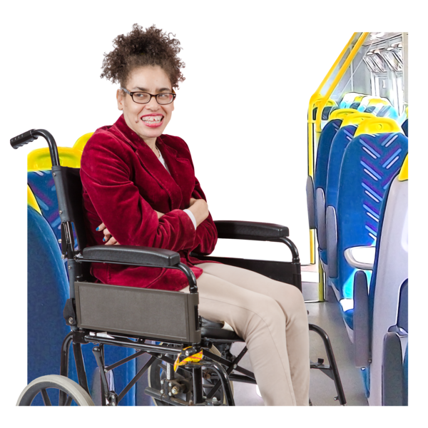

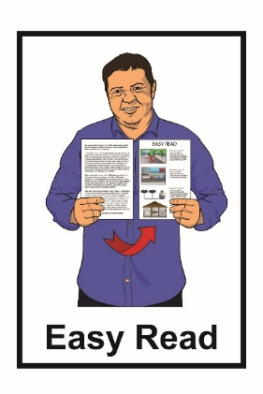

August 2022
Before you read this

This is a long document.

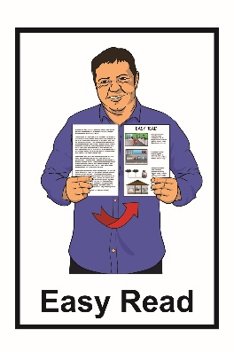
While it is written in Easy Read it can be hard for some people to read a document this long.

Some things you can do to make it easier are:
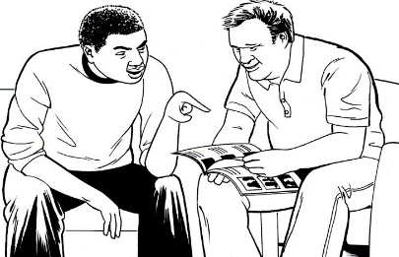
- read a few pages at a time

- have someone support you to understand it.

What you will find in this document

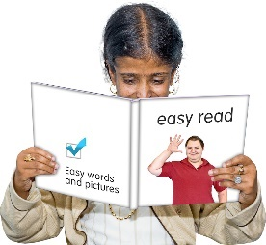
Page number:

What is this document about? 4

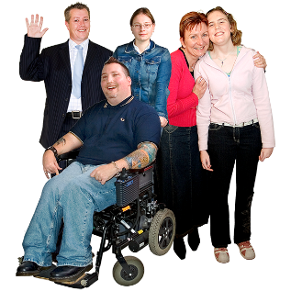
Disabled people in
New Zealand 6

How the research team
did the study 8

What the research team
found out 11
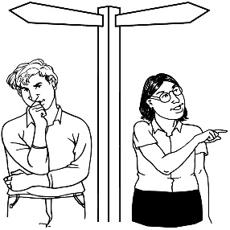

What changes are
needed? 20

Page number:

New kinds of transport 24

Where to find more
information 26

What is this document about?

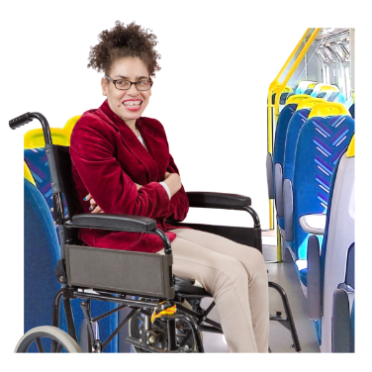
This Easy Read document is about a study into transport experiences of disabled people in Aotearoa New Zealand in 2021.
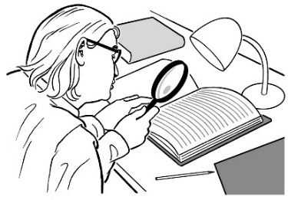
A study is looking for answers to a question you have and writing down what you find out.

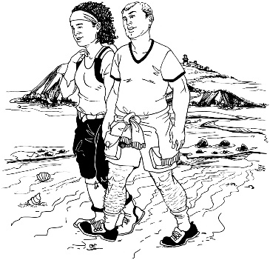
Transport means things like getting to places by:

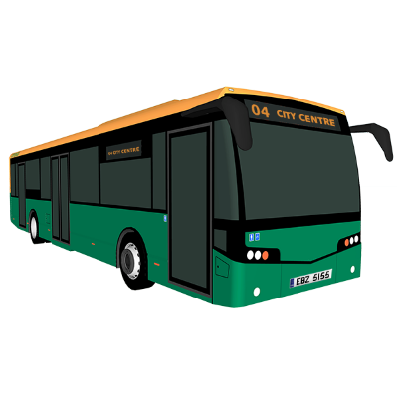
- walking

- car

- bus / trains
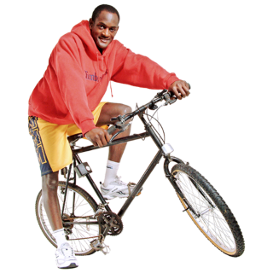
- taxi / Uber

- bike / scooter.
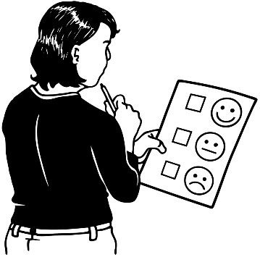
Experiences means what using transport was like for people.

This study was done for Waka Kotahi - New Zealand Transport Agency by:
- MRCagney
- the Disabled Persons Assembly
- Confluence Consulting.

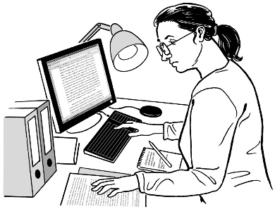
In this Easy Read document we will call these groups the research team.

This Easy Read document will tell you what the main things the research team found out by doing this study.

Disabled people in New Zealand

1 out of every 4 people in New Zealand is disabled.

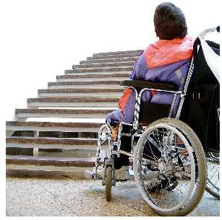
In their report the research team said that:

Disability is when the world does not work well for someone so they find it harder to live their life than other people do.

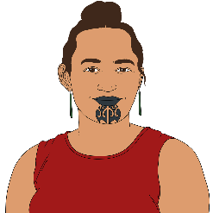
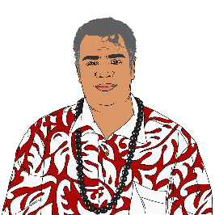
Some groups of people are more likely to be disabled than others like:
- Māori
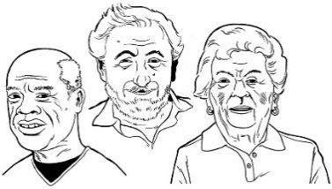
- Pacific peoples
- older people.

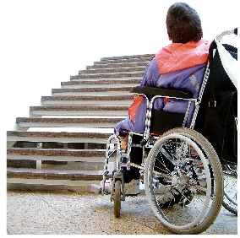
Being disabled can make it harder for people to get around because of things like:
- finding it hard to walk / move around
- disabled women being more likely to be victims of crime than people who are not disabled
- some disabled people not having enough money to pay for transport.

How the research team did the study

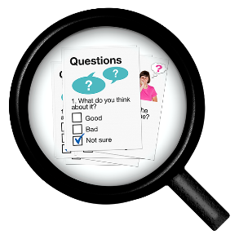
To do the study the research team:

- read many other studies

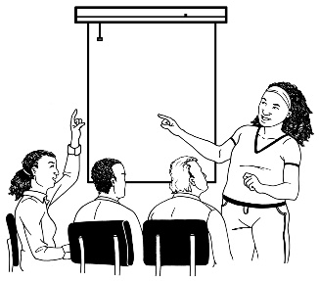
- did surveys with over 15 thousand people

- had workshops / meetings where over 1 hundred people came.

A survey is a list of questions we ask people to help us understand their experiences.

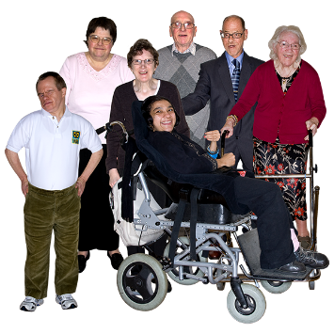
The people who answered the survey questions were:
- disabled people
- people without disabilities
- people who design transport systems like engineers.

The research team made sure the surveys could be done by a lot of disabled people by having surveys:
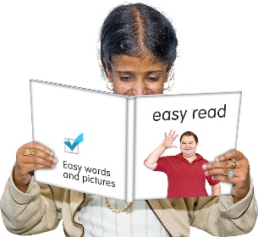
- in New Zealand Sign Language
- in Easy Read
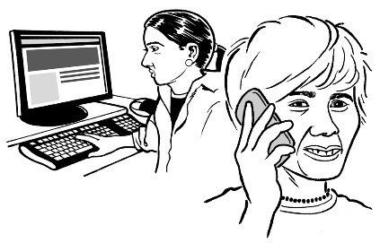
- on the computer so they could be read out loud by screen-readers
- over the phone.

The research team also did a survey of how people got around during the COVID-19 lockdown.

For the lockdown survey the research team asked about the experiences of:
- disabled people
- people without disabilities.

What the research team found out

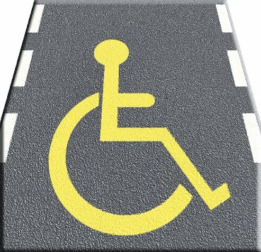
The research team found there are still a lot of problems when it comes to transport for disabled people.

1. Public transport

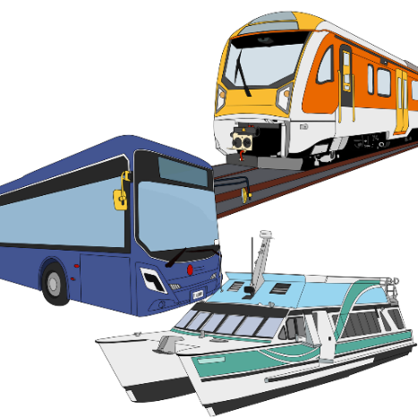
There are a lot of problems that make it hard for disabled people to use public transport like:
- trains
- buses

- ferries.

Some of the problems with public transport are:

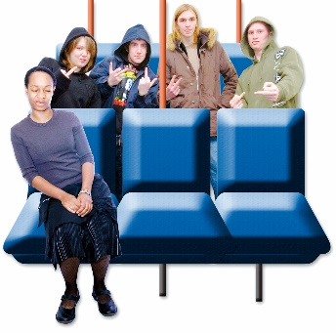
- sometimes the drivers are not friendly
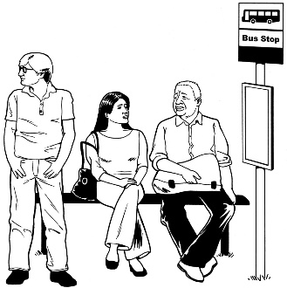
- sometimes the passengers are not friendly
- the bus sometimes does not show up at all

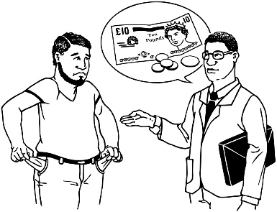
- sometimes the trip costs too much money for disabled people because they have less money than other people.

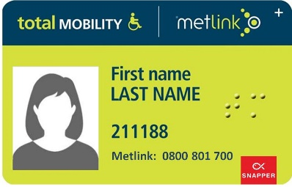
2. Total Mobility scheme

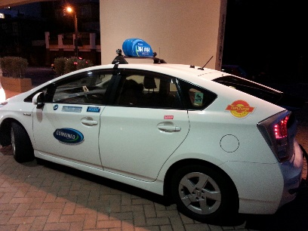
The Total Mobility scheme is a card that some disabled people can use to make the taxi fare cost less money.

The research team found that:

- Total Mobility taxis still cost too much for many disabled people to use them

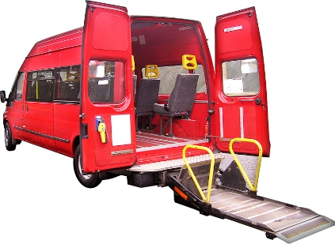
- some disabled people live in places where there are not any taxis

- there are not enough taxis that can carry a wheelchair
- the rules for Total Mobility can be confusing because they are not the same everywhere.
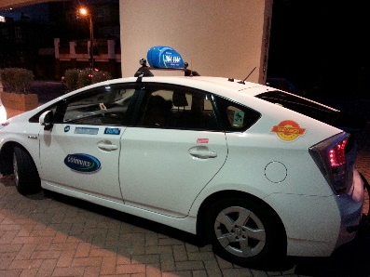
The research team also talked to the transport providers that offer Total Mobility.

They said Total Mobility could work better if:

- the rules about Total Mobility were the same all over New Zealand
- taxis could give discounts
- there were more taxis that can take wheelchairs
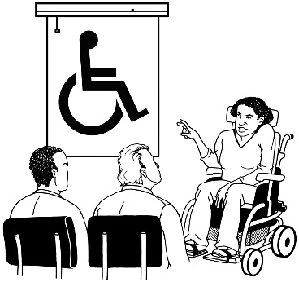
- there was more training for taxi drivers to make them good drivers for disabled people.

3. Transport using cars

Cars can include:

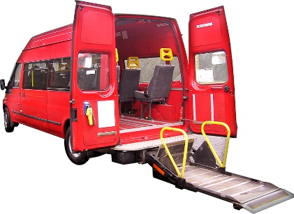
- vans

- utes

- SUVs.

The research team found that:
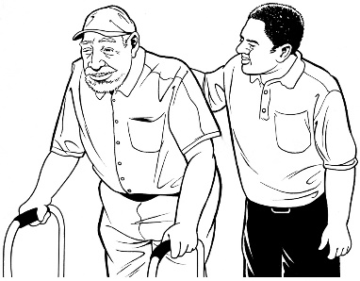
- having a car can cost too much money
- some disabled people like using a car because it is easier than:
- walking
- catching a bus
- catching a train.
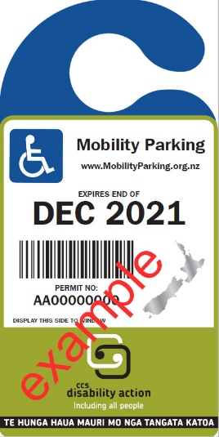
4. Mobility Parking permits

A Mobility Parking permit lets disabled people park their car in the marked mobility parks.

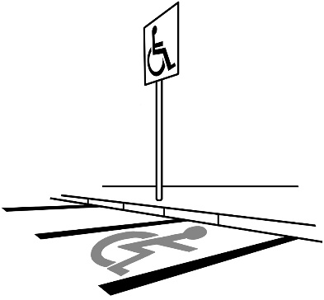
The research team found that people with a Mobility Parking permit like being able to use it because it is easier to find a car park.

Some of the problems that were found are that:
- sometimes people without a permit use the mobility car parks
- people without permits using the mobility parks is a problem which makes it harder for disabled people to go places.
5. Walking
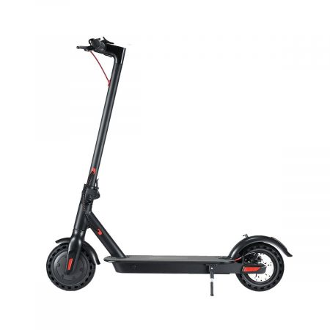
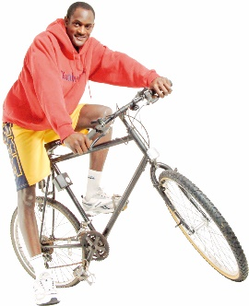
The research team found that some disabled people do not like using footpaths because they might be hit by someone on a:
- scooter
- bike.

The research team found that disabled people are worried that people who design footpaths:

- do not think about the needs of disabled people
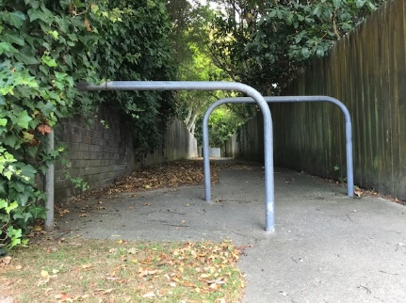
- do not always know how hard it can be for disabled people to get around streets.
6. Transport during the
COVID-19 lockdown

The COVID-19 lockdown was when everyone had to follow a lot of rules to stop people from getting sick with the COVID-19 virus.

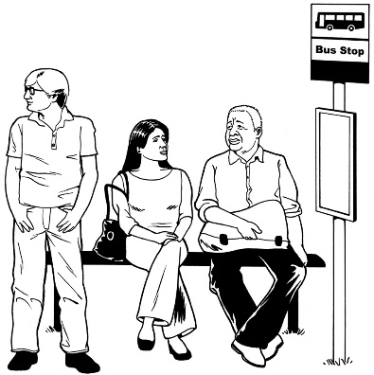
Disabled people said that getting around during lockdown was hard for them for a lot of reasons like:

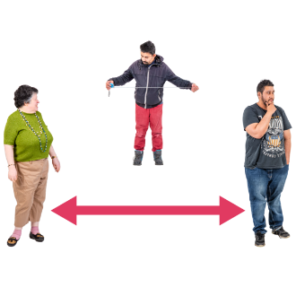
- it was hard to stay away from other people
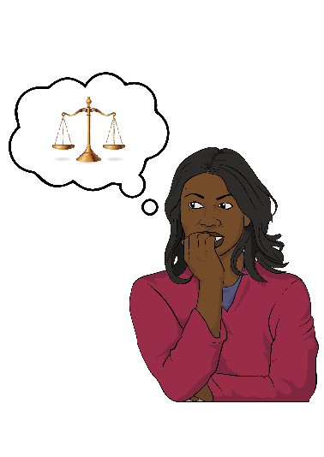
- It was hard to move away from someone else on a footpath.

Disabled people said that they were also worried about getting COVID-19 if they left their homes.

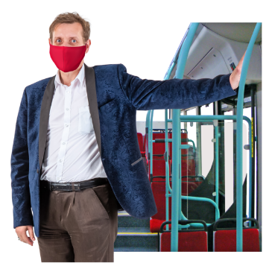
Disabled people said they had problems using the buses like:
- they did not know where to sit
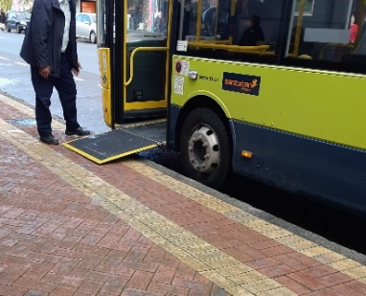
- some of the ramps on the buses did not work.

What changes are needed?

The research team found that the problems disabled people have when using transport in New Zealand have not changed in a long time.
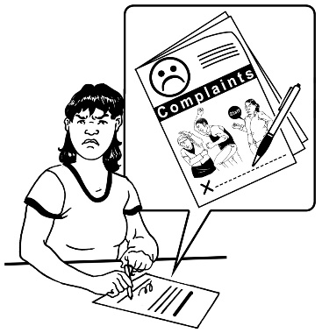

Disabled people feel like they need to complain a lot just to get around.

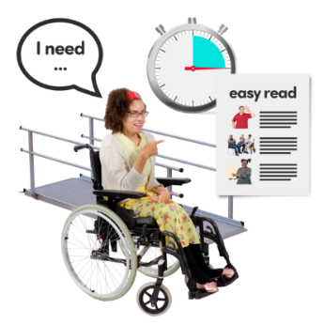
The problems that were found are not easy to fix but it is important that they are fixed.

It is important that the people who are in charge of transport think about how to make transport easier for disabled people.

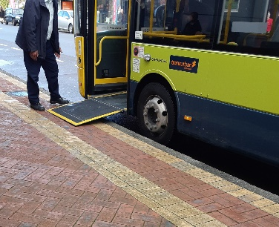
The research team thinks some things that need to happen to make transport easier for disabled people are:
- all public transport needs to be easier to use for everyone
- taxis should be even cheaper than they already are for disabled people
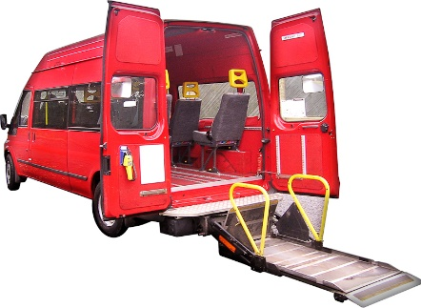
- there should be more taxis
- there should be more taxis that take wheelchairs.

The research team also thinks that people in charge of transport in New Zealand need to:
- check that the streets can be used easily by all disabled people

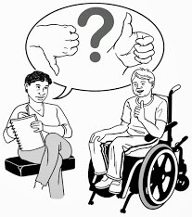
- work to fix transport issues all over New Zealand by asking disabled people:
- where they go
- where they do not go.

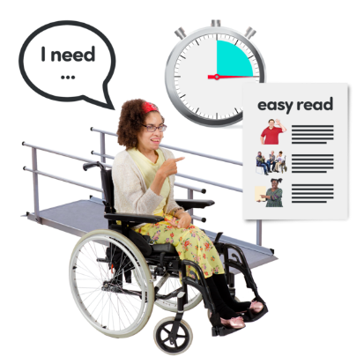
The research team also thinks that everyone who works in transport needs to:
- learn about disabled people
- learn how to meet the needs of disabled people.

The research team thinks that people who study transport should:
- ask disabled people questions a lot more
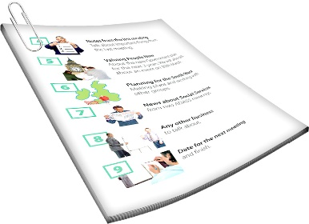
- make the questions easy to understand so more people can answer them.

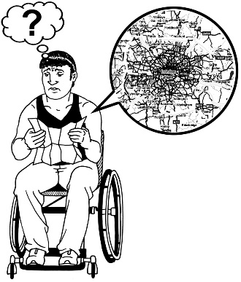
The research team also think that disabled people can have a lot of problems in trying to live a good life.

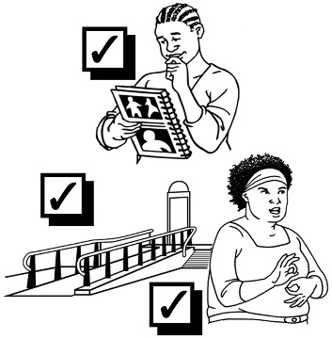
It would be a lot better if we could fix some of these problems.

Fixing some of these problems would make life much fairer for disabled people.

New kinds of transport

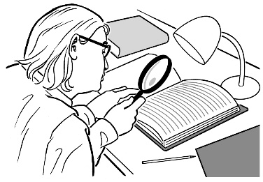
The research team also looked at new kinds of transport that might be good for disabled people.

The research team found:
- some good things
- some bad things.

One of the kinds of transport the team looked at was self-driving cars.

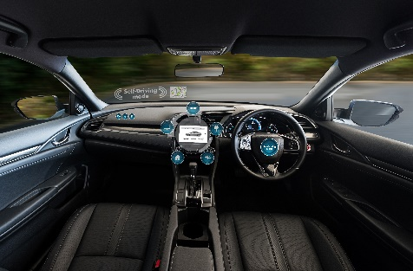
A self-driving car is:

- a car that is not driven by a person

- driven by a computer.
Self-driving cars are already being made in other countries.

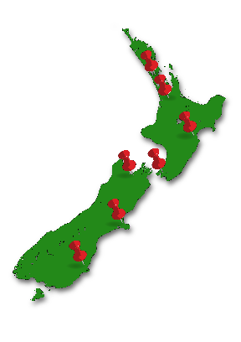
Self-driving cars cannot be used in New Zealand yet.

We did not find a lot of new kinds of transport that would be good for disabled people to use to get around.

Where to find more information

You can contact Waka Kotahi - NZ Transport Agency if you have any questions about the study.

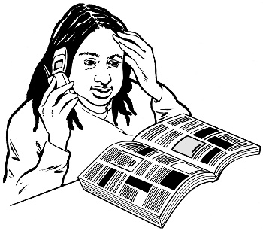
We are having a lot of people call us on the phone for things that need fixing right now.

This means we are asking people to email us their questions to:

WakaKotahiResearch@nzta.govt.nz

We will answer any questions we get as soon as we can.

We answer all questions in under 10 working days.

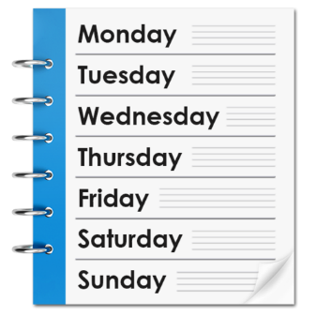
A working day is:
- the days Monday to Friday
- not weekends
- not public holidays like Christmas day.

You can find out more about Waka Kotahi - NZ Transport Agency on our website at:

https://nzta.govt.nz

This information has been written by the Waka Kotahi - NZ Transport Agency.

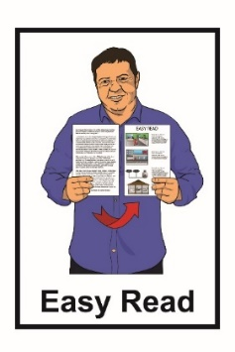
It has been translated into Easy Read with advice from the Make It Easy service of People First New Zealand Inc. Ngā Tāngata Tuatahi.

The ideas in this document are not the ideas of People First New Zealand Inc. Ngā Tāngata Tuatahi.
Make It Easy uses images from:
- Changepeople.org

- Photosymbols.com

- Sam Corliss
- Huriana Kopeke-Te Aho.

Some images have been provided by Waka Kotahi - NZ Transport Agency,

All images used in this Easy Read document are subject to copyright rules and cannot be used without permission.

